

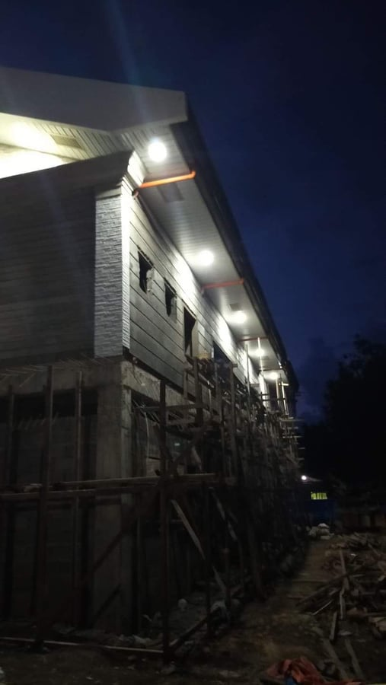



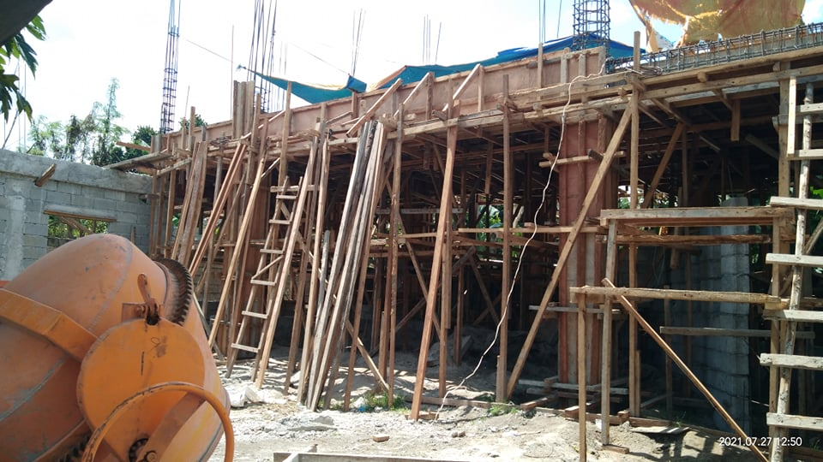







JULY REPORT

There are pictures of baptisms by two of the churches helped by PMD; this is what it is all about, the salvation of souls, following in scriptural baptism and a church to teach them the truths of God’s Word. The baptistery at Bethsada is unique; the candidate is seen being submerged.

We began the month in West Virginia, by enjoying time with our grand-Children, Zack, Katie and the Great-grands Carter and Will. Zack is pastor of First Baptist Inwood, WV. While there we had the opportunity to present PMD and to preach for Maplewood Baptist Church, Martinsburg, WV and First Baptist Church of Green Valley, Monrovia, MD.

After returning home we attended Camp Number One, a Family Camp at Pine Springs where I again had the privilege of teaching the adult class and pitching for the preachers against the boys.

I am happy to report that we had another outstanding month; for the project fund we received $8,059.89, the remainder of the financial report is located on the back. We have several new contributors joining us this month for which we are so thankful. It is such a blessing to see how God is blessing this Ministry in spite of all that is going on in the world.

The work on the buildings at Berean MBC #14, and Emanuel, MBC # 15 are moving along quite well, however because of the Covid they have been forced to use a skeleton crew. Pastor Abner will fill in for us by traveling to Ozamis City, in September to inspect the work at Berean MBC, project # 14, and visit with the church.

Everything is coming together for number sixteen and hopefully by next month we will be able to announce who it will be.

We are still planning on traveling to the Philippines next year, but only God knows for sure, we will leave it with Him.

Again, thank you for all of your prayers and support, God loves you and so do we.

Wayne Stringer

1. Baptism at Bethsada MBC # 9 in their baptistery;

2. Since January they have baptized 22.

3. . Baptism July at Good News MBC # 13.

4.Getting ready to pour the concrete at Emanuel MBC #15.

4





1. The Old man can still pitch a softball.

2. Const. # 15

3. Berean MBC, #14 lights on at night.

4. Lights on, seen from highway.





**Register of monies received from U.S. Churches in Jul 2021:**

Abounding Grace BC, Choctaw, OK $ 75.00

**PHILIPPINE TRAVEL FUND:**

**Beginning Balance 07/01/21: $8,313.78**

Anonymous, White Rock, Center, TX $100.00

Cross Roads MBC, Hughes Springs, TX $ 50.00

Hart, Bubba & Janet, De Kalb, TX $ 55.00

Stringer, Wayne, De Kalb, TX $ 35.00

**Total Recv’d for Travel – Jul: $ 240.00**

**Travel Fund Ending Balance: $8,553.78**

**----------------------------------------**

**DESIGNATED FOR SALARY:**

Anonymous, White Rock MBC, Center, TX $100.00

Antioch BC, Center, TX $ 83.50

Avery MBC, Avery, TX $ 50.00

Bethel MBC, Ashdown, AR $100.00

Bethel MBC, Texarkana, TX $200.00

Bethlehem MBC, Joaquin, TX $ 25.00

Corinth BC, Timpson, TX $100.00

Crestview MBC, Arlington, TX $ 60.00

Eastside BC, Broken Bow, OK $ 50.00

Faith BC, Homer, LA $ 51.70

FBC of Inwood, Inwood, WV $225.00

Hawthorne MBC, Shelbyville, TX $ 50.00

Hillcrest MBC, Paris, TX $ 57.00

Kirbyville MBC, Kirbyville, TX $ 50.00

Liberty MBC, Mt Pleasant, TX $ 50.00

Line Creek MBC, Ida, LA $203.70

Maple Grove MBC, Minden, TX $ 25.00

New Friendship MBC, Benton, AR $140.23

Old Salem BC, Center, TX $200.00

Roquemore MBC, Henderson, TX $ 24.98

White Rock MBC, Center, TX $500.00

Zion Hill BC, Henderson, TX $125.00

**Total Salary Received in Jul: $2,471.11**

**----------------------------------------**

**LOVE OFFERINGS:**

Bethel MBC,Texarkana, TX $250.00

Oak Grove MBC,Austin, AR $223.00

Parr,Jerry&Martha,Mt Pleasant,TX $500.00

Anonymous, White Rock MBC, Center, TX $ 25.00

Antioch BC, Center, TX $ 83.50

Avery MBC, Avery, TX $ 50.00

Bassett Road BC, Palestine, TX $ 25.00

Bethel MBC, Ashdown, AR $100.00

Bethlehem Baptist Association, TX $554.00

Bethlehem MBC, Joaquin, TX $ 25.00

Blue Ribbon MBC, Lone Grove, OK $150.00

Bogata MBC, Bogata, TX $100.00

Concord MBC, Concord, AR $325.00

Cross Roads MBC, Hughes Springs, TX $100.00

Echo Hills MBC, Redwater, TX $ 82.93

Elumbaugh, R.B. & Nina, Center, TX $ 25.00

Ethel MBC, Antlers, OK $105.00

Fellowship BC, Joaquin, TX $ 25.00

Fellowship MBC, Pasadena, TX $ 50.00

First BC, Delight, AR $100.00

Grace MBC, Auburn, GA $ 25.00

Green Mountain MBC, Rutland, VT $350.00

Hawthorne MBC, Shelbyville, TX $ 50.00

Hemphill MBC, Hemphill, TX $ 25.00

Hopewell MBC, Ashdown, AR $163.00

Johntown MBC, Bogata, TX $ 60.00

Kirbyville MBC, Kirbyville, TX $ 50.00

Landmark MBC, Athens, TX $100.00

Liberty MBC, McKinney, TX $250.00

Liberty MBC, Mt Pleasant, TX $ 50.00

Liberty Hill MBC, Mt Pleasant, TX $223.00

Line Creek MBC, Ida, LA $203.70

Longbranch MBC, Carthage, TX $ 50.00

Marlow BC, Marlow, OK $200.00

Mt Carmel MBC, Bradford, AR $ 50.00

Mt Pleasant BC, Bradford, AR $100.00

Nevill’s Chapel MBC, Mt Pleasant, TX $524.82

New Columbia BC, Timpson, TX $1,000.00

New Haven MBC, Clarksville, TX $100.00

New Liberty MBC, Garland, TX $ 50.00

North Loop BC, Crockett, TX $100.00

Oakridge MBC, Maud, TX $397.00

Old Salem BC, Center, TX $200.00

Payne Springs BC, Mabank, TX $135.53

Quaker Avenue MBC, Lubbock, TX $ 25.00

San Augustine MBC, San Augustine, TX $ 15.00

Spann’s Chapel Church, Center, TX $300.00

Sublett Road BC, Arlington, TX $ 50.00

Timpson MBC Youth, Timpson, TX $ 50.00

Two Grey Hills MBC, Newcomb, NM $ 25.00

**Balance in Project Fund $ 44,305.71**

**Amount still set aside for Emanuel MBC $ 26,000.00**

**Amount needed for transfers $ 120.00**

**Amount received for Number 16 $ 18,185.71**

Unity MBC, DeWitt, AR $450.00

Unity MBC, Stuart, VA $ 25.00

Vaughn, Ronnie/Sheila, Hitchcock, TX $100.00

Westside MBC, New Boston, TX $274.91

Westview BC, Gatesville, TX $ 25.00

White Rock MBC, Center, TX $ 75.00

Yellow Ridge MBC, Broaddus, TX $ 62.50

Zion Hill BC, Henderson, TX $125.00

**Total Received for Project-Jul: $ 8,059.89**

**Previous Balance: $36,245.82**

**New Bank Balance: $44,305.71**