

1. ABA Luncheon

2. Bethlehem B.C. Kirby, AR

3. First B.C. Inwood, WA

4. Finishing Aud. Pj. # 14

5. Center Bottom, Const.

Number 15

***1. The first and second pictures are of the crowd that attended the Luncheon sponsored by Philippine Mission Development.***

***2. The third is Filipino Pastors gathered to give Pastor Abner support as he spoke live by internet***

***3. The fourth is Pastor Abner speaking live from the Philippines.***

June 2021 Report

June was a busy, but enjoyable month, there was a lot going on. We had two buildings, number 14 and 15, under construction at the same time while collecting funds for a third, number 16. Number 14 is working on the inside of the Sanctuary while Project number 15 is in the process of drying in their building.

The support continues to be good, for the month we received **$** 4,794.17 designated to the project; the remainder of the financial statement is on the back if this report.

We were privileged to present PMD and preach for the good people of Bethlehem Baptist Church, Kirby, AR and their good Pastor, Jack Herring; the last Sunday in June I was thankful to be with the good people of First Baptist Church of Inwood, VA and their Pastor Zack Stringer.

The National meeting of the ABA was a real blessing, we had the opportunity to visit with many as they came by our booth, and we made numerous new friends and enjoyed visiting with many old ones.

For us, the highlight of the meeting was the luncheon sponsored and paid for by our Sponsoring Church and Friends of PMD. There was between 140 and 150 present. While we were enjoying a great lunch in Charleston, WV there was a group of pastors in the Philippines enjoying a meal at the same time, only it was 13 hrs. difference in time and was 1:00 A.M.? These men were gathered to give encouragement to Pastor Abner Tuazon, pastor of Ind. Calvary MBC, Angeles City, the co-sponsor of PMD in the Philippines. Who spoke to us by way of the internet? It appeared that everyone present enjoyed the meal and Pastor Abner sharing how Philippine Mission Development has and is helping the Filipino Churches learn to step out on faith and begin to do things themselves.

We still do not know when we will be able to visit, this is in the hands of the Lord, so we will wait on Him. Should any church desire for us to visit and present PMD, just call one of the phone numbers listed above, it will be our pleasure to share our Ministry.

Again, thank you for your prayers and support, God loves you and so do we.

***Wayne Stringer Director of Promotions in the US***

***Abner Tuazon Director of Promotions in the Philippines***





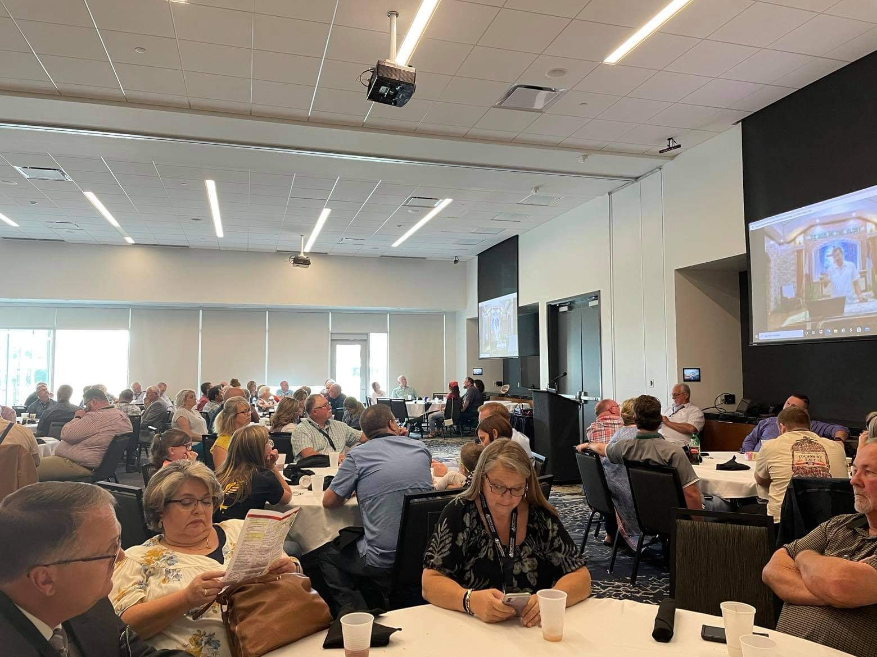



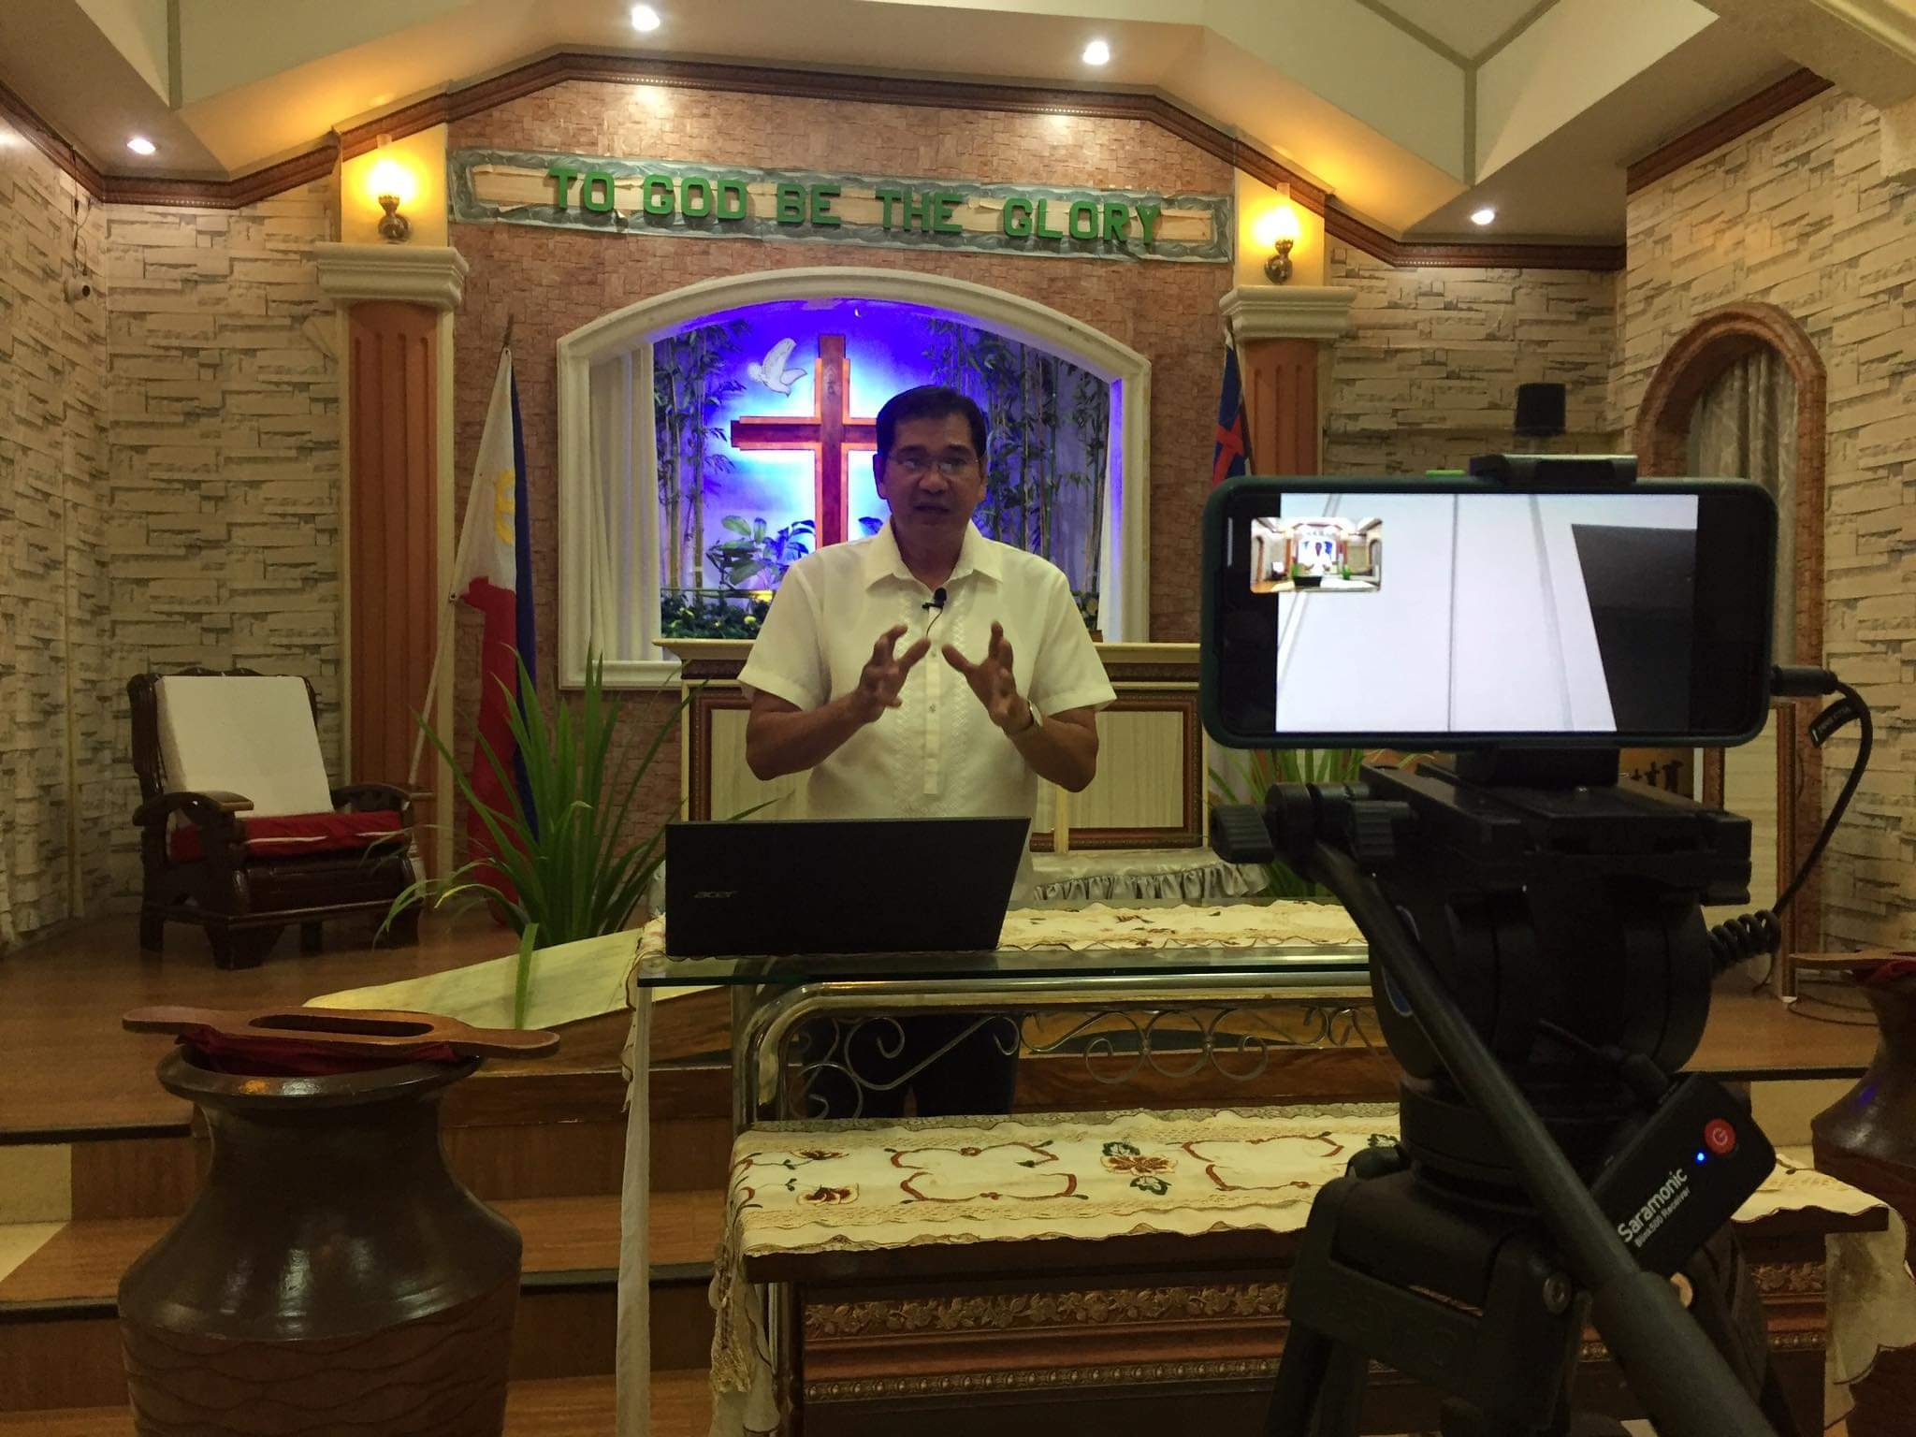





**Philippine Mission Development**

P.O. Box 31

New Boston, TX 75559

***Wayne Stringer Director of Promotions***

Phone 903-277-3590 903-667-9048

**www.philippinemissiondevelopment.org**

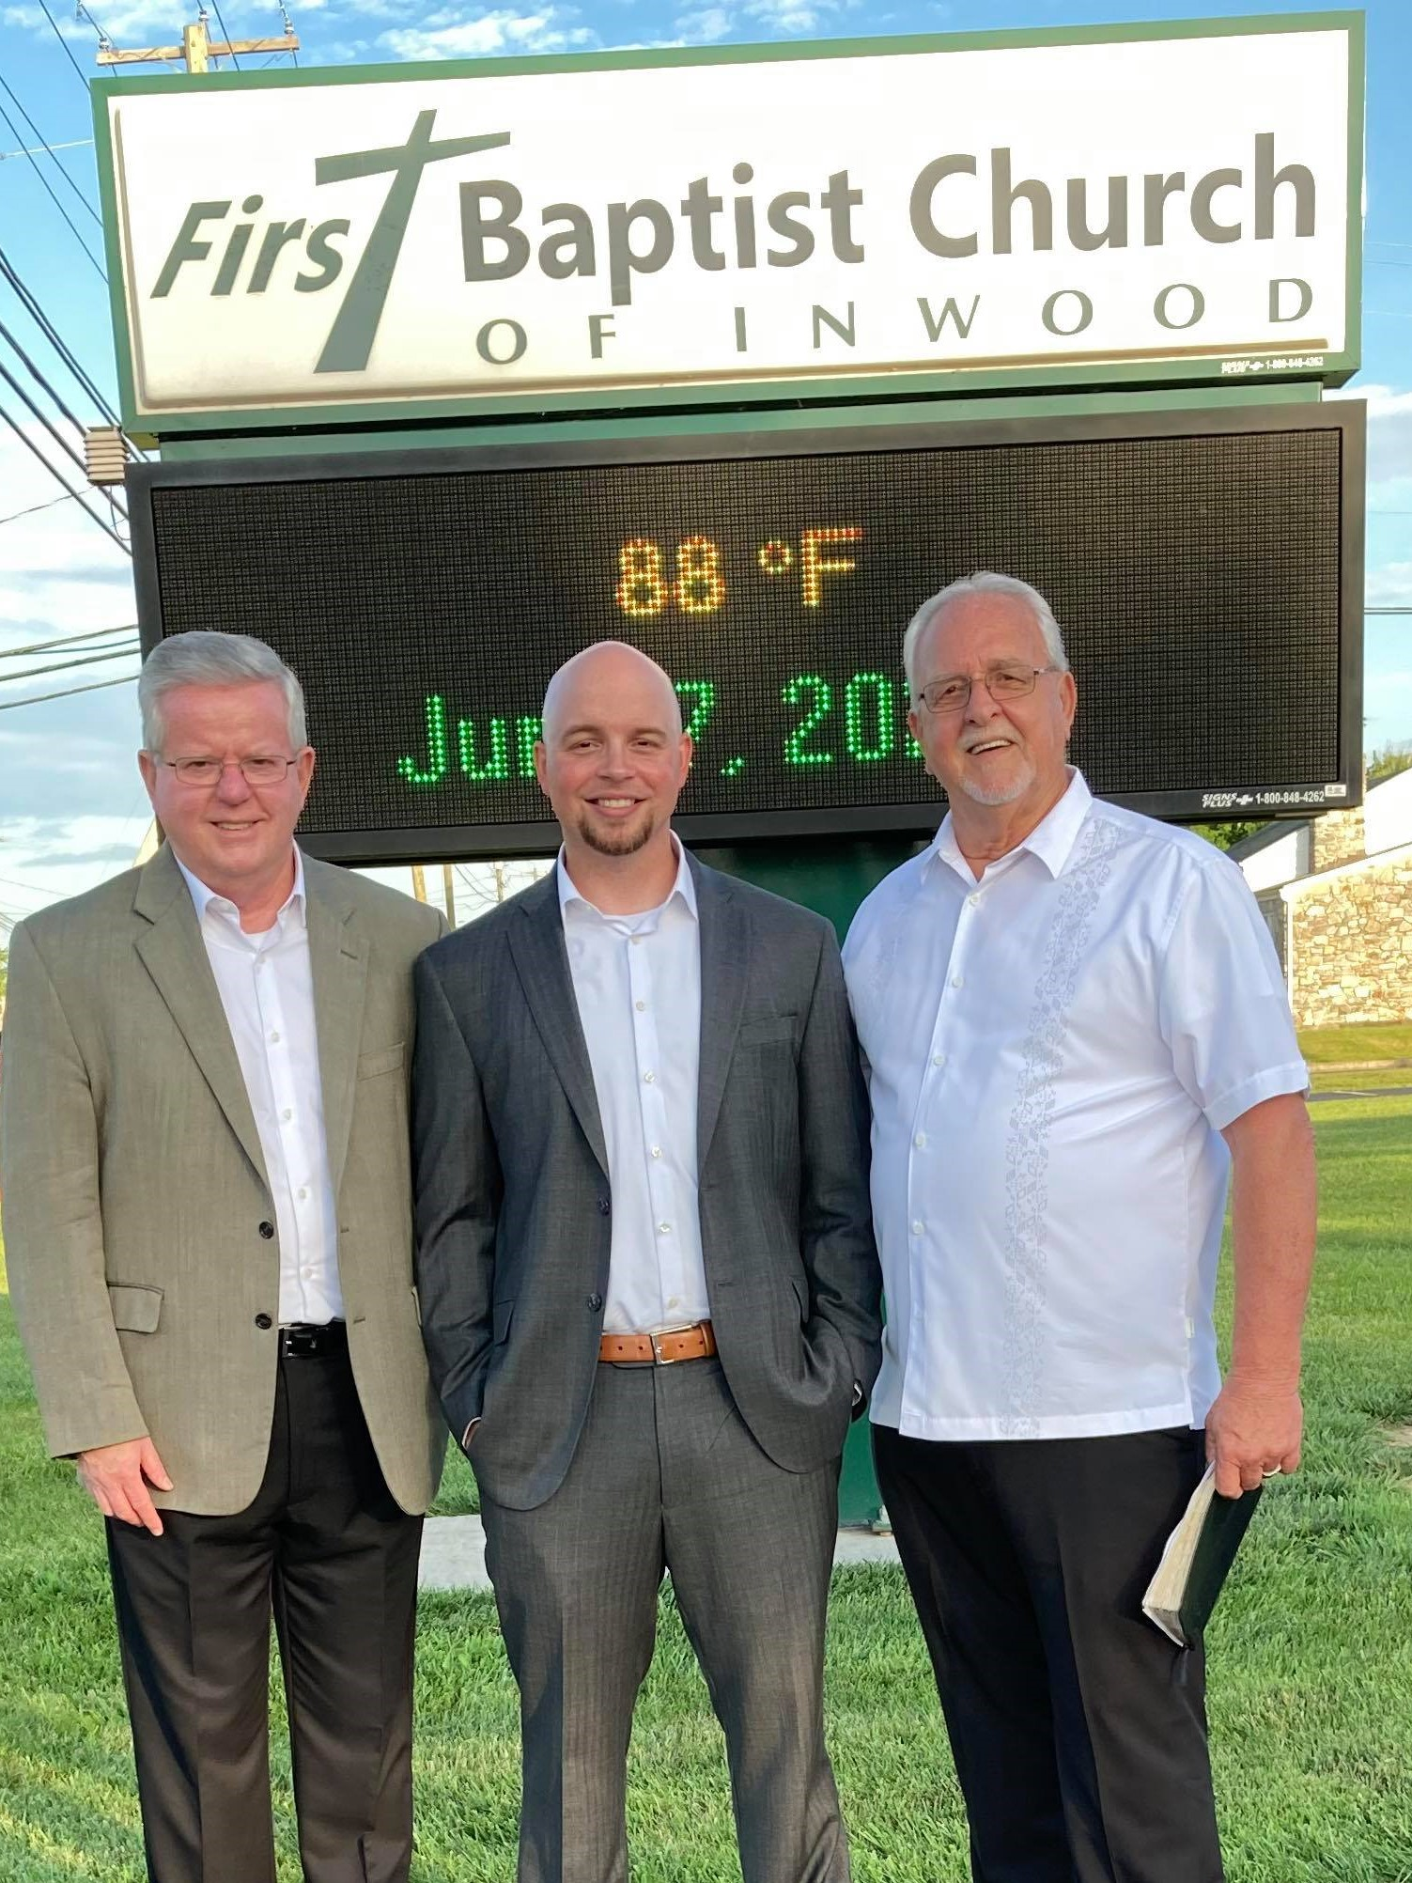



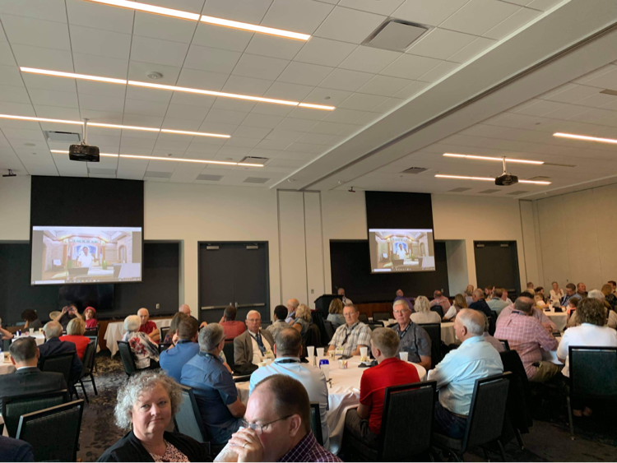

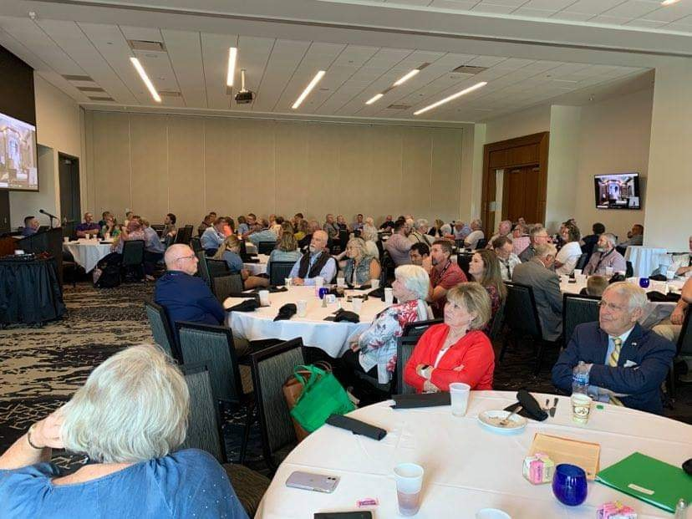

**PHILIPPINE TRAVEL FUND:**

**Beginning Balance 06/01/21: $7,986.28**

Anonymous, White Rock, Center, TX $100.00

Cross Roads MBC, Hughes Springs, TX $100.00

Hart, Bubba & Janet, De Kalb, TX $ 55.00

Rocky Branch MBC, Naples, TX $ 37.50

Stringer, Wayne, De Kalb, TX $ 35.00

**Total Recv’d for Travel – Jun: $ 327.50**

**Travel Fund Ending Balance: $8,313.78**

**----------------------------------------**

**DESIGNATED FOR SALARY:**

Anonymous, White Rock MBC, Center, TX $100.00

Antioch BC, Center, TX $ 83.50

Austin Chapel MBC, De Kalb, TX $ 50.00

Avery MBC, Avery, TX $ 50.00

Bethel MBC, Texarkana, TX $200.00

Bethlehem MBC, Joaquin, TX $ 25.00

Corinth BC, Timpson, TX $100.00

Crestview MBC, Arlington, TX $ 60.00

Eastside BC, Broken Bow, OK $ 50.00

Faith BC, Homer, LA $ 25.90

FBC of Inwood, Inwood, WV $100.00

Hawthorne MBC, Shelbyville, TX $ 50.00

Hillcrest MBC, Paris, TX $126.00

Kirbyville MBC, Kirbyville, TX $ 50.00

Maple Grove MBC, Minden, TX $ 25.00

New Friendship MBC, Benton, AR $149.83

Rocky Branch MBC, Naples, TX $ 37.50

Roquemore MBC, Henderson, TX $ 33.78

White Rock MBC, Center, TX $500.00

Zion Hill BC, Henderson, TX $125.00

**Total Salary Received in Jun: $1,941.51**

**LOVE OFFERINGS:**

**Unity MBC, DeWitt, AR $ 450.00**

**----------------------------------------**

Abounding Grace BC, Choctaw, OK $ 75.00

Anonymous, White Rock MBC, Center, TX $ 25.00

Antioch BC, Center, TX $ 83.50

Austin Chapel MBC, De Kalb, TX $ 25.00

Avery MBC, Avery, TX $ 50.00

Bethlehem MBC, Joaquin, TX $ 25.00

Blue Ribbon MBC, Lone Grove, OK $150.00

Bogata MBC, Bogata, TX $ 50.00

Concord MBC, Concord, AR $325.00

Cross Roads MBC, Hughes Springs, TX $200.00

Echo Hills MBC, Redwater, TX $ 77.85

Elumbaugh, R.B. & Nina, Center, TX $ 25.00

Ethel MBC, Antlers, OK $ 49.00

Fellowship BC, Joaquin, TX $ 25.00

Fellowship MBC, Pasadena, TX $ 50.00

First BC, Delight, AR $100.00

Grace MBC, Auburn, GA $ 25.00

Grace Temple BC, Mt Pleasant, TX $ 25.00

Green Mountain MBC, Rutland, VT $175.00

Hawthorne MBC, Shelbyville, TX $ 50.00

Hopewell MBC, Ashdown, AR $160.00

Johntown MBC, Bogata, TX $ 60.00

Kirbyville MBC, Kirbyville, TX $ 50.00

Landmark MBC, Athens, TX $100.00

Landmark MBC, Vilonia, AR $ 51.36

Longbranch MBC, Carthage, TX $ 50.00

Marlow BC, Marlow, OK $200.00

Mt Carmel MBC, Bradford, AR $ 50.00

Mt Carmel MBC, Ladies, Bradford, AR $ 30.00

Mt Pleasant BC, Bradford, AR $100.00

New Haven MBC, Clarksville, TX $100.00

New Liberty MBC, Garland, TX $ 50.00

North Loop BC, Crockett, TX $100.00

Oakridge MBC, Maud, TX $344.00

Parsons, Terry & Sherry, Benton, AR $400.00

Payne Springs BC, Mabank, TX $163.46

Quaker Avenue MBC, Lubbock, TX $ 25.00

San Augustine MBC, San Augustine, TX $ 15.00

Sublett Road BC, Arlington, TX $ 50.00

Timpson MBC Youth, Timpson, TX $ 50.00

Two Grey Hills MBC, Newcom, NM $ 25.00

Unity MBC, DeWitt, AR $500.00

Unity MBC, Stuart, VA $ 25.00

Vaughn, Ronnie/Sheila, Hitchcock, TX $100.00

Westview BC, Gatesville, TX $ 25.00

White Rock MBC, Center, TX $ 75.00

Whitton, Cecil & Kay, Timpson, TX $135.00

Zion Hill MBC, Batesville, AR $ 25.00

Zion Hill BC, Henderson, TX $125.00

**Total Received for Project-Jun: $ 4,794.17**

**Interest Paid – (6/30/21): $ 12.50**

**Previous Balance: $55,489.15**

**Withdrawal–Emmanuel BC (6/1/21) -$ 8,000.00**

**Withdrawal Fee – (6/1/21) -$ 5.00**

**Withdrawl-Berean MBC (6/4/21) -$ 8,000.00**

**Wire Fee – (6/4/21) -$ 40.00**

**Withdrawal–Emmanuel BC (6/28/21) -$ 8,000.00**

**Withdrawal Fee – (6/28/21) -$ 5.00**

**New Bank Balance: $36,245.82**

All funds have been sent to Number Fourteen Berean MBC

All funds have been collected for Emanuel MBC, # 15; $24,000.00 has been wired, leaving a balance of $26,000.00 set aside for this project.

Balance in Bank in Project Account $36,245.82

Amount reserved for #15 $26,000.00

Three draws at $40.00 per draw. - 120.00

Amount collected for project #16 $10,125.82