



**Philippine Mission**

**Development**

P.O. Box 31

New Boston, TX 75559

***Wayne Stringer Director of Promotions***

Phone 903-277-3590 903-667-9048

**www.philippinemissiondevelopment.org**

May Report 2021

#15

# 14

Number 14

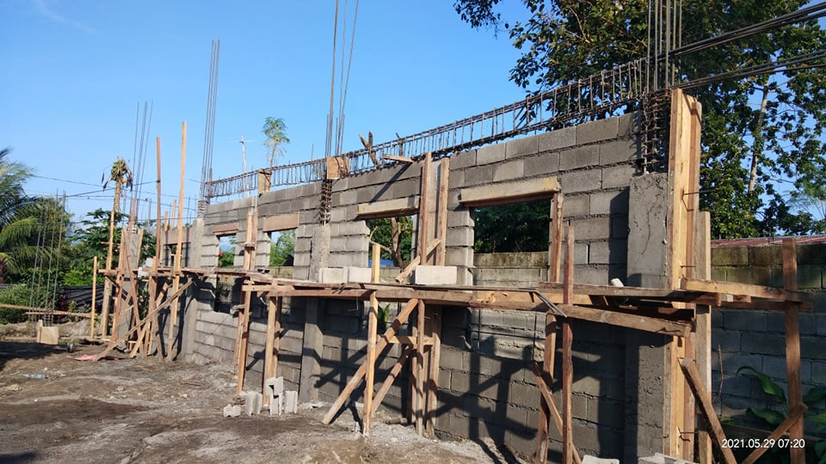

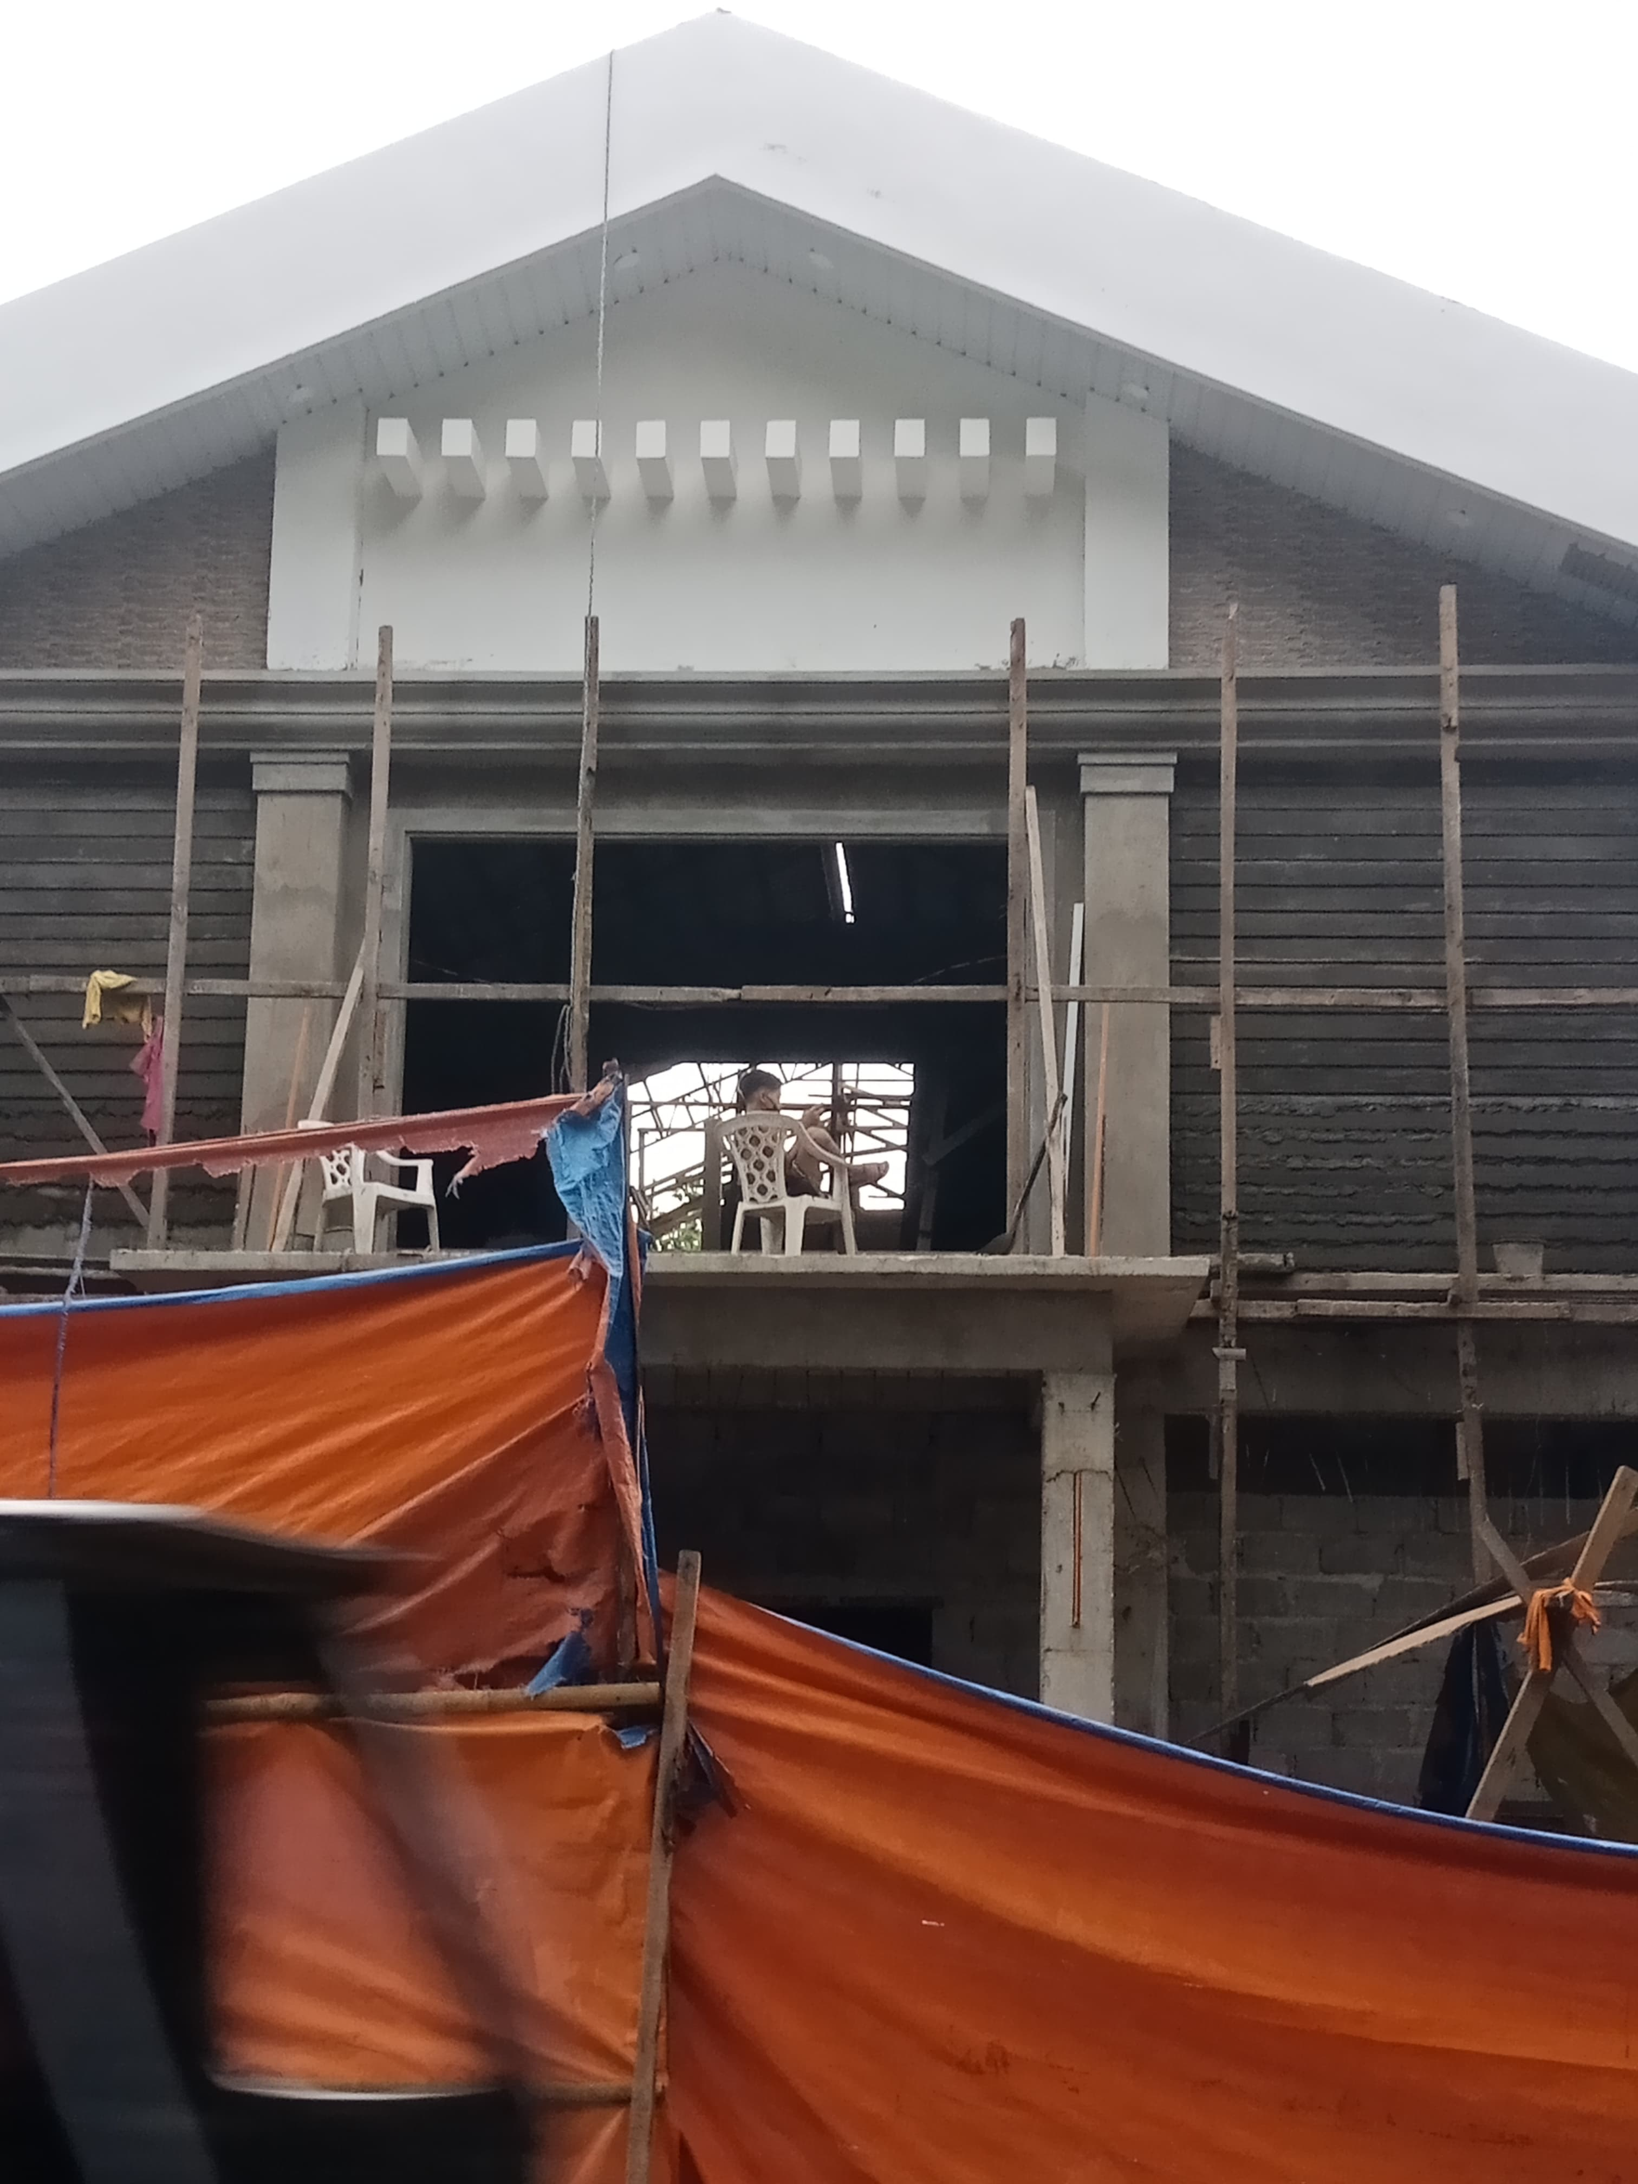

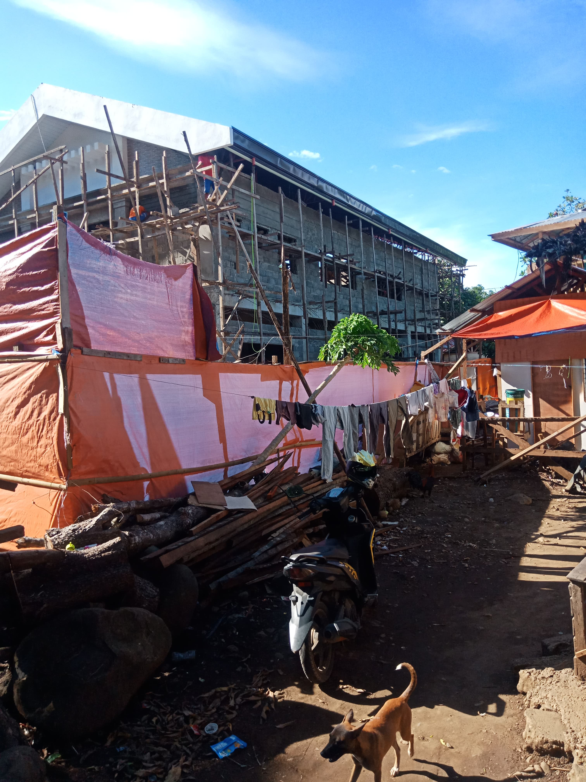

God is so good; through churches and individuals He has blessed this Ministry far above anyone’s expectations. We have two projects going at this time, and have all the funds needed for these projects and $5,449.15 towards #16. If you checked the financial statement last month, you found where I made a mistake. I showed more in the bank than the statement showed, it was my mistake not Janet’s, she had the right amount. Thanks for keeping me straight.

The last two months have been record breakers, we received $7,827.96 for the projects in May, and the rest of the report is on the back.

We are excited to see the churches that have been helped continue to improve and add to their building. Good News MBC, #13 is adding SS Rooms and a Conference Room/fellowship room. Magalang MBC #12 has just added some improvements and A/C to the Auditorium. Butuan MBC Project #4 has added in the past to their building, and now are breaking ground to build an activities Building to accommodate their huge Youth Ministry. Ind. Calvary will be organizing one of their Missions in Iloilo next month; they need the red American Baptist Hymnals for their Mission, if any one has any, contact me.

We are praying that things will settle down so we can travel there in February 2022.

I am excited about the National ABA meeting in Charleston, WV. After the meeting we will be visiting with several churches in that area and spending some time with our grand-son in Inwood.

I am available if any church would like for us to visit and share PMD, just send me a text or call.

On behalf of White Rock MBC and all of us at PMD, we thank you for your love of Missions, Missionaries and this Ministry. May God continue to bless each and every one of you? God loves you and so do we.

Wayne Stringer