



**Philippine Mission**

**Development**

P.O. Box 31

New Boston, TX 75559

***Wayne Stringer Director of Promotions***

Phone 903-277-3590 903-667-9048

**www.philippinemissiondevelopment**

Pastor Abner visited the sight of Project #14, inspected and encouraged the workers and church members. Abner is important to the success of PMD, he is the eyes and ears and has helped us and the projects.

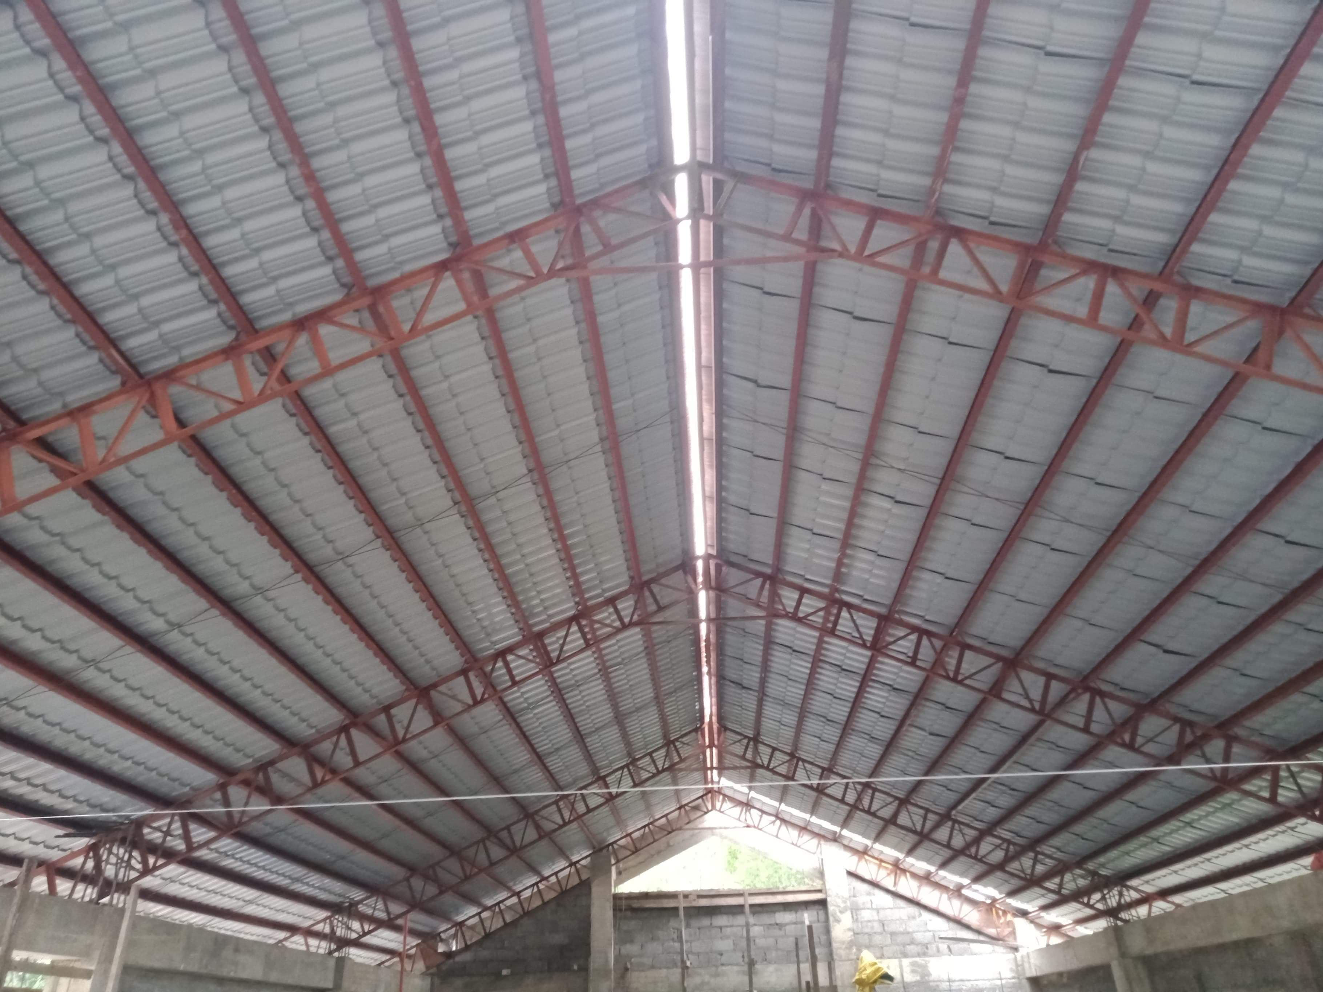

The month of March was a very good month, offerings were very good. Number 14, Berean Missionary Baptist Church should be completed sometime in July. Emanuel MBC had their ground breaking and has begun digging the footings. God has blessed with all the funds for both Emanuel and Berean with $ 2,628.66 toward project #16. For the month of March we received **$6,321.27, one of the best months we have had sence our beginning.** We have not determined just who number #16 will be, there are several interested, but it will depend upon which church has all things required to comply.

We are looking forward to the National Meeting. Our Sponsoring Church and several individuals have joined together to sponsor a Lunch on Wednesday of the meeting to show our appreciation to all the churches and individuals who have made this great Ministry work and include others might be interested in seeing what PMD is all about. If everything works out Pastor Abner Tuazon, who is pastor of Ind. Calvary MBC the Co-Sponsor of PMD in the Philippines. He will be speaking by the internet and will be sharing how important PMD has been to the growth of God’s work through the churches associating with the American Baptist Association of Churches.

Thank each and everyone of you that are praying and supporting this great ministry, God loves you and so do we.

Wayne Stringer

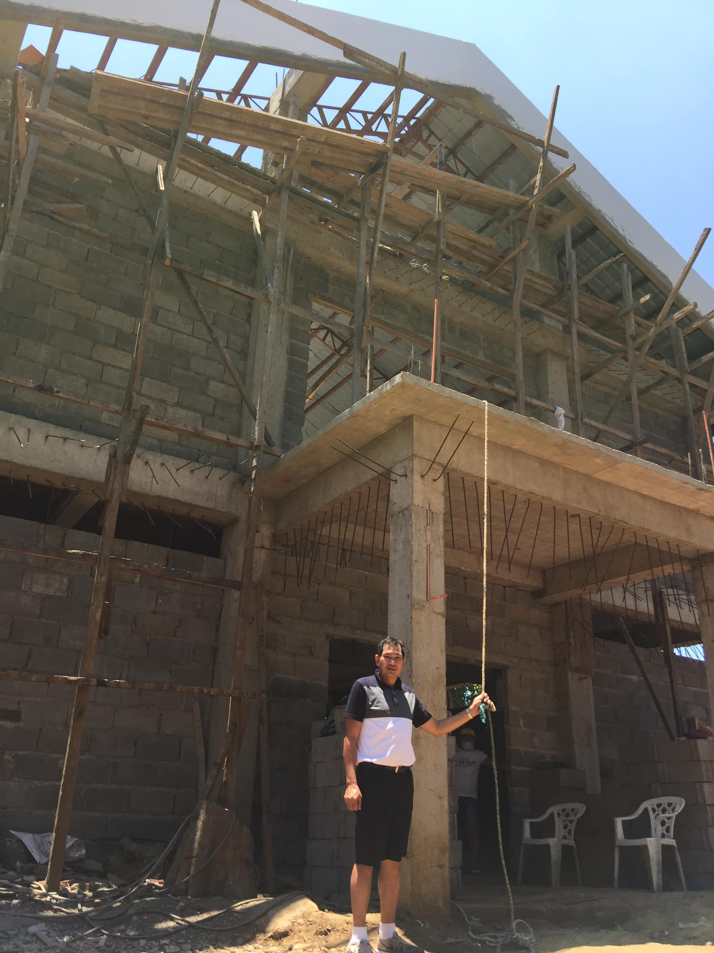

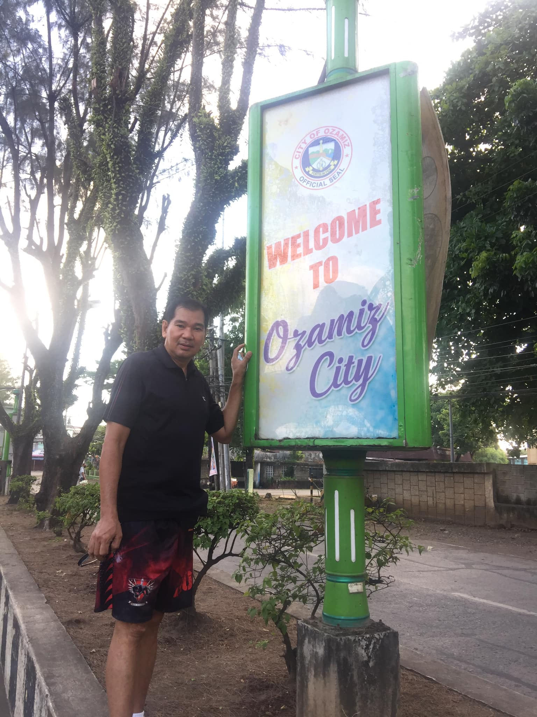

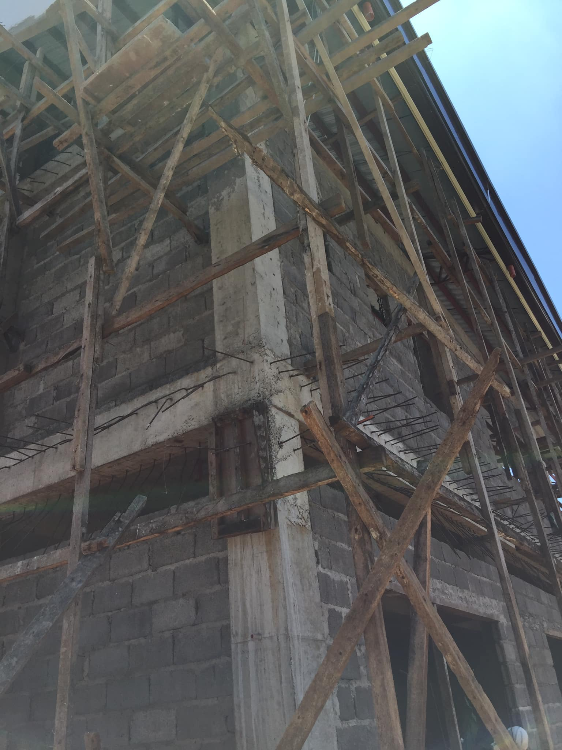

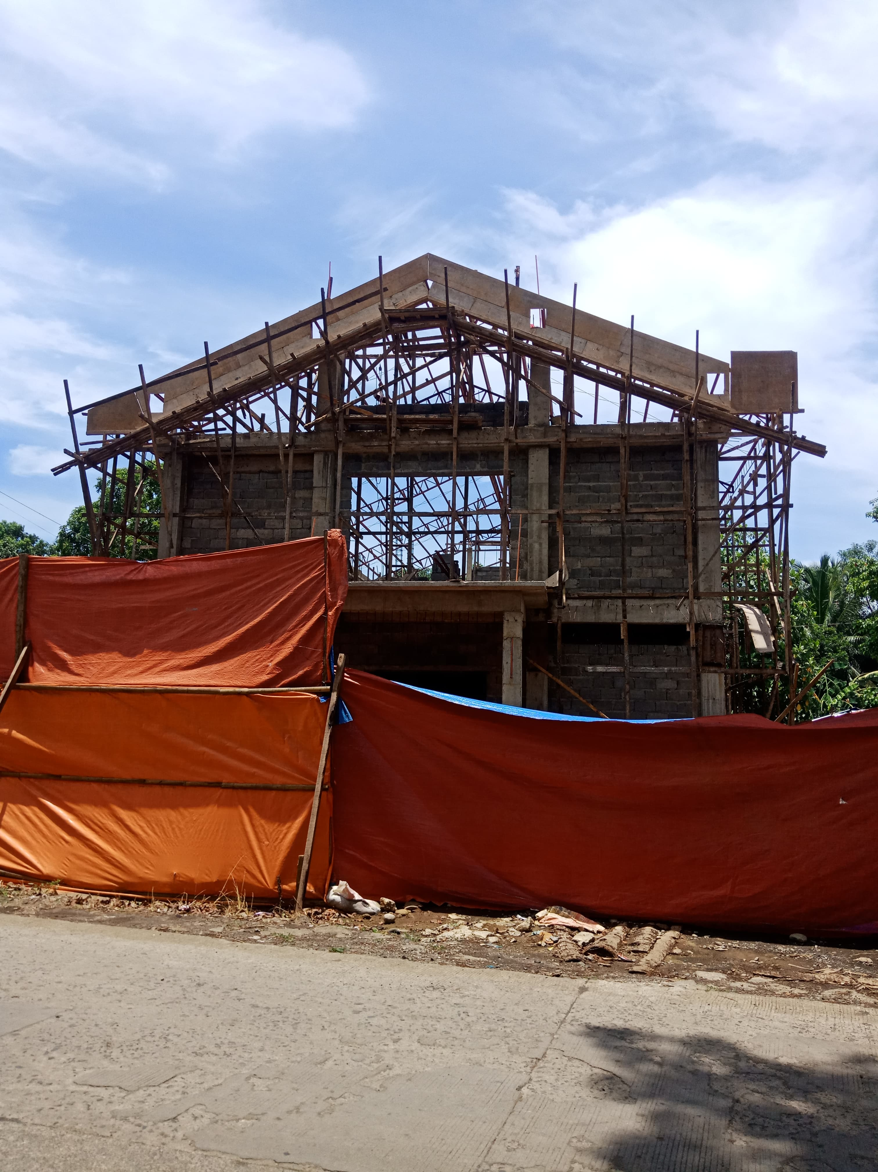

**Register of monies received from U.S. Churches in April 2021:**

Abounding Grace BC, Choctaw, OK $ 75.00

**PHILIPPINE TRAVEL FUND:**

**Beginning Balance 04/01/21: $7,371.28**

Anonymous, White Rock, Center, TX $100.00

Hart, Bubba & Janet, De Kalb, TX $ 55.00

Stringer, Wayne, De Kalb, TX $ 35.00

**Total Recv’d for Travel – Apr: $ 190.00**

**Travel Fund Ending Balance: $7,561.28**

**----------------------------------------**

**DESIGNATED FOR SALARY:**

Anonymous, White Rock $100.00

Antioch BC, Center, TX $ 83.50

Austin Chapel MBC, De Kalb, TX $ 50.00

Avery MBC, Avery, TX $ 50.00

Bethel MBC, Texarkana, TX $100.00

Bethlehem MBC, Joaquin, TX $ 25.00

Corinth BC, Timpson, TX $100.00

Crestview MBC, Arlington, TX $ 60.00

Faith BC, Homer, LA $ 47.03

FBC of Inwood, Inwood, WV $100.00

Hawthorne MBC, Shelbyville, TX $ 50.00

Hillcrest MBC, Paris, TX $ 52.00

Kirbyville MBC, Kirbyville, TX $ 50.00

Liberty MBC, Mt Pleasant, TX $ 50.00

Line Creek MBC, Ida, LA $194.56

Maple Grove MBC, Minden, TX $ 25.00

New Friendship MBC, Benton, AR $152.30

Old Salem MBC, Center, TX $200.00

Roquemore MBC, Henderson, TX $ 25.54

White Rock MBC, Center, TX $500.00

Zion Hill BC, Henderson, TX $125.00

**Total Salary Received in Apr: $2,139.93**

**----------------------------------------**

**LOVE OFFERINGS:**

Eastside MBC, $ 200.00

Broken Bow, OK

Parr, Jerry & Martha

Mt Pleasant, TX $ 500.00

Anonymous, White Rock MBC, Center, TX $ 25.00

Antioch BC, Center, TX $ 83.50

Austin Chapel MBC, De Kalb, TX $ 25.00

Avery MBC, Avery, TX $ 50.00

Bethlehem MBC, Joaquin, TX $ 25.00

Blue Ribbon MBC, Lone Grove, OK $150.00

Bogata MBC, Bogata, TX $ 50.00

Concord MBC, Concord, AR $300.95

Eastside MBC, Broken Bow, OK $100.00

Echo Hills MBC, Redwater, TX $ 50.00

Elumbaugh, R.B. & Nina, Center, TX $ 25.00

Ethel MBC, Antlers, OK $ 66.00

Fellowship BC, Joaquin, TX $ 25.00

Fellowship MBC, Pasadena, TX $ 50.00

First BC, Delight, AR $100.00

Grace MBC, Auburn, GA $ 25.00

Green Mountain MBC, Rutland, VT $175.00

Hawthorne MBC, Shelbyville, TX $ 50.00

Hemphill MBC, Hemphill, TX $ 50.00

Hopewell MBC, Ashdown, AR $117.00

Kirbyville MBC, Kirbyville, TX $ 50.00

Landmark MBC, Athens, TX $100.00

Landmark MBC, Vilonia, AR $ 53.23

Liberty MBC, McKinney, TX $ 50.00

Liberty MBC, Mt Pleasant, TX $ 50.00

Liberty Hill MBC, Mt. Pleasant, TX $100.00

Line Creek MBC, Ida, LA $194.56

Longbranch MBC, Carthage, TX $ 50.00

Marlow BC, Marlow, OK $200.00

Marsh Road BC, Woodbridge, VA $1,500.00

Mt Carmel MBC, Bradford, AR $ 50.00

Mt Pleasant BC, Bradford, AR $100.00

Nevills Chapel MBC, Mt Pleasant, TX $725.77

New Haven MBC, Clarksville, TX $100.00

New Liberty MBC, Garland, TX $ 50.00

North Loop BC, Crockett, TX $100.00

Oakridge MBC, Maud, TX $103.00

Old Salem MBC, Center, TX $200.00

Payne Springs BC, Mabank, TX $150.26

Quaker Avenue MBC, Lubbock, TX $ 25.00

San Augustine MBC, San Augustine, TX $ 15.00

Timpson MBC Youth, Timpson, TX $ 50.00

Two Grey Hills MBC, Newcom, NM $ 25.00

Unity MBC, Stuart, VA $ 25.00

Vaughn, Ronnie/Sheila, Hitchcock, TX $200.00

Westside MBC, New Boston, TX $ 77.00

Westview BC, Gatesville, TX $ 25.00

White Rock MBC, Center, TX $ 75.00

Balance beginning April 1 $62,420.00

Amount received in April $ 6,321.27

Amount to give account $68,741.27

Checks 31.60

Wire transfer Berean MBC #14 $ 8,000.00

Wire fee $ 40.00

Balance beginning May $60,668.66

Amount reserved for Berean MBC #14 $ 8,000.00

40.00

Amount reserved for Emanuel MBC #15 $50.000.00

Amount collected for #16 $ 2,628.66

Total in bank $60,668.66

Whitton, Cecil & Kay, Timpson, TX $135.00

Zion Hill BC, Henderson, TX $125.00

**Total Received for Project-Apr: $ 6,321.27**

**Previous Balance: $57,411.52**

**Check Order: (4/14/21) - $ 31.60**

**Wire – Berean MBC (4/15/21) - $ 8,000.00**

**Wire Fee – (4/15/21) - $ 40.00**

**New Bank Balance: $55,661.19**