

**Philippine Mission**

**Development**

P.O. Box 31

New Boston, TX 75559

***Wayne Stringer Director of Promotions***

Phone 903-277-3590 903-667-9048

**www.philippinemissiondevelopment**



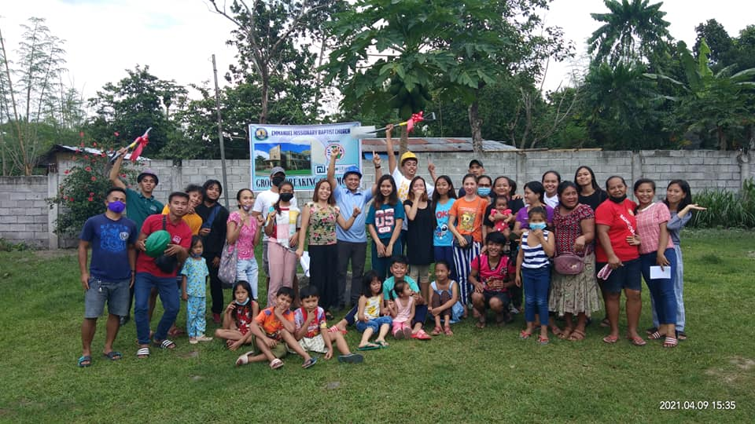



MARCH REPORT

March was a very good month for PMD, God truly blessed. Emanuel MBC had their ground breaking. For the first time we will have two buildings going at the same time. Number fourteen, Berean MBC has placed the trusses and purlin in place and ordered the metal; the building will soon be in the dry.

All of the churches who have been helped are reporting gains in their growth. Souls are being saved and the churches are growing and taking care of business as a church should; taking care of their pastor and promoting missions.

Offerings for the month were excellent, designated for the project fund was 5,008.48. As reported previously, all the funds for fourteen have been collected and at the end of March, we only need $3,660.00 to complete the amount needed for number fifteen. We should be announcing soon who will be the precipitant for number 16.

The national meeting will soon take place, there was no meeting last year because of the Pandemic, I am praying for a good meeting this year and looking forward to seeing everyone in Charleston, WV, Lord willing. We are praying for a good attendance, especially among our regular supporters, because we are planning something special

Again , we thank each of you for your continued support and prayers, God loves you and so do we!

Wayne Stringer, Director

Pictures #1 & 2 Congregation of Emanuel MBC at groundbreaking.

Picture #3 Trusses project # 14

