

**Philippine Mission Development**

P.O. Box 31

New Boston, TX 75559

***Wayne Stringer Director of Promotions***

Phone 903-277-3590 903-667-9048

**www.philippinemissiondevelopment.org**



February 2021 Report

February was an eventful month. It began with a Memorial Service for Witt Hammer in Round Rock. While there, I was scheduled to be with Faith MBC the following Sunday. However, this was canceled because of the Memorial Services for Pastor Ronnie Pipes. He was a faithful Pastor, a strong supporter of PMD and a dear friend. Then on the 20th my sister-in-law passed away and it was requested I do her Services. In all of this Texas was blanked with a severe winter storm and I had to cancel an appointment in Oklahoma. Hopefully things are be back to normal, to some degree and we will again be able to travel among the churches.

The work on Berean MBC in Ozamiz City has not slowed down, it is progressing well and they are at present fabricating the trusses for the roof. All roof beams have been poured and when the trusses are finished they will go up with the roof. This will be one of the largest buildings we have been a part of.

We had another good month of offering. We received through the office of PMD for the project fund $4,206.53; this gives us $36,309.40 for the Emanuel MBC, General Santos City, Polomolok, South Cotabato, project # 15. The rest of the financial report is on the back of this report.

Again, thank you for all of your faithful support. I cannot emphasis enough how important each church and individual is to this Ministry. Through you, PMD is making a difference in the Philippines.

God loves you and so do I, May God continue to bless in a mighty way.

**Wayne Stringer**

Fabricated trusses

Fabricating trusses

Fabricating trusses

Steel in roof beams

Pouring roof trusses

Inner wall

First floor SS rooms

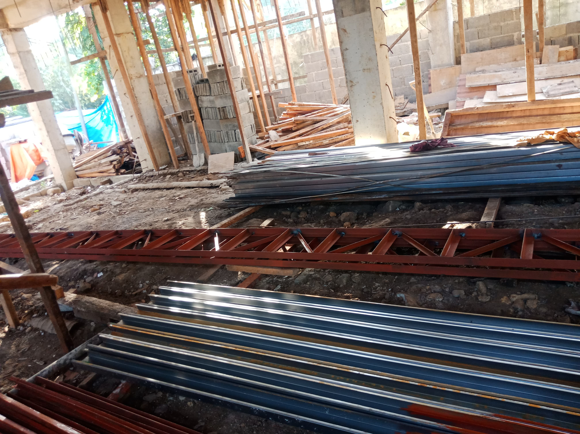

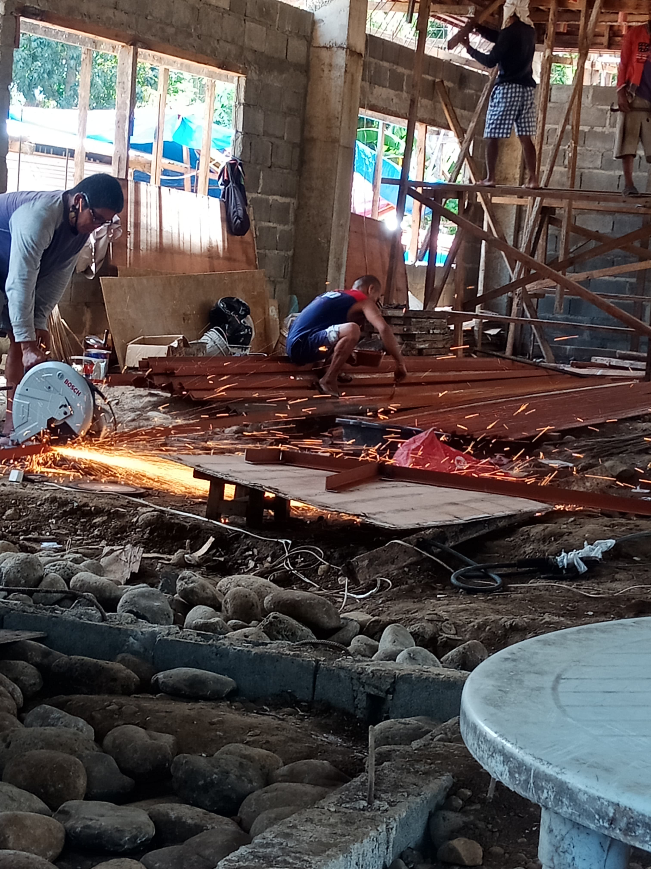

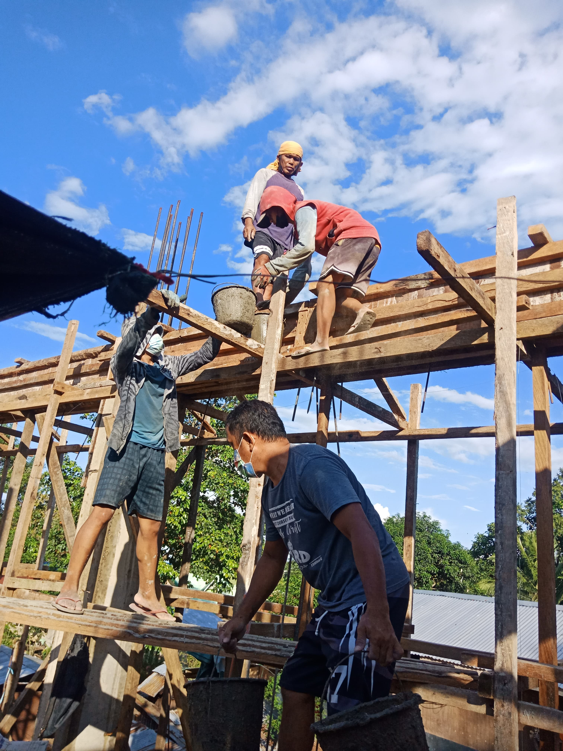

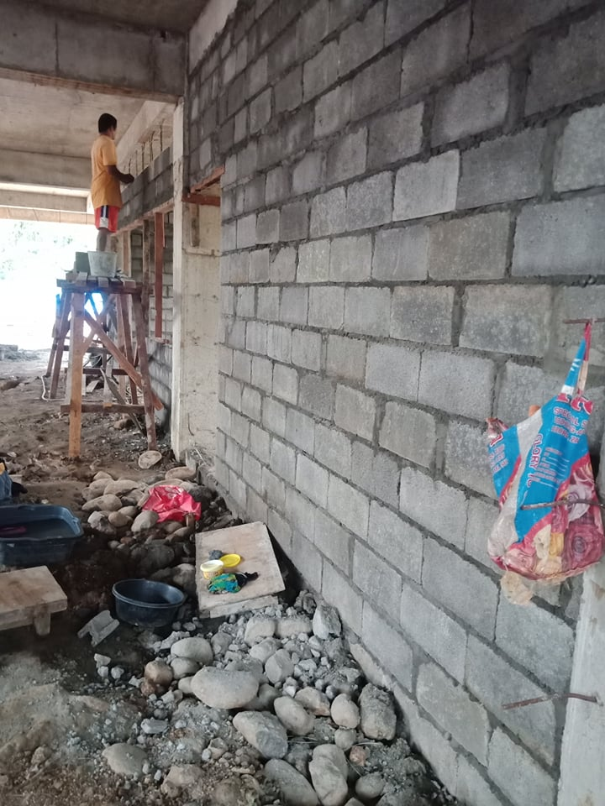

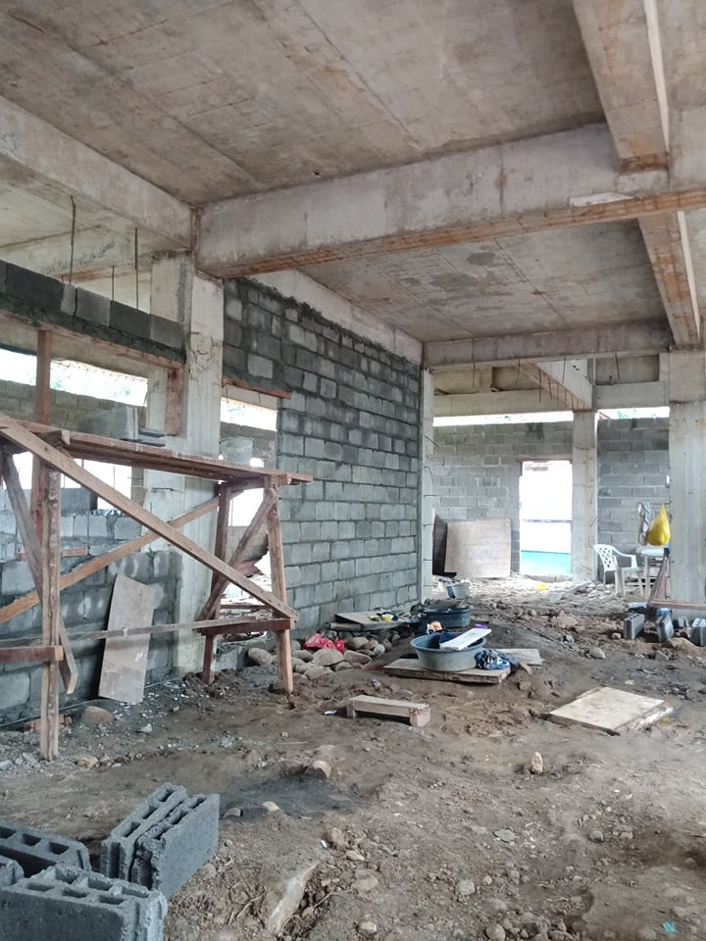

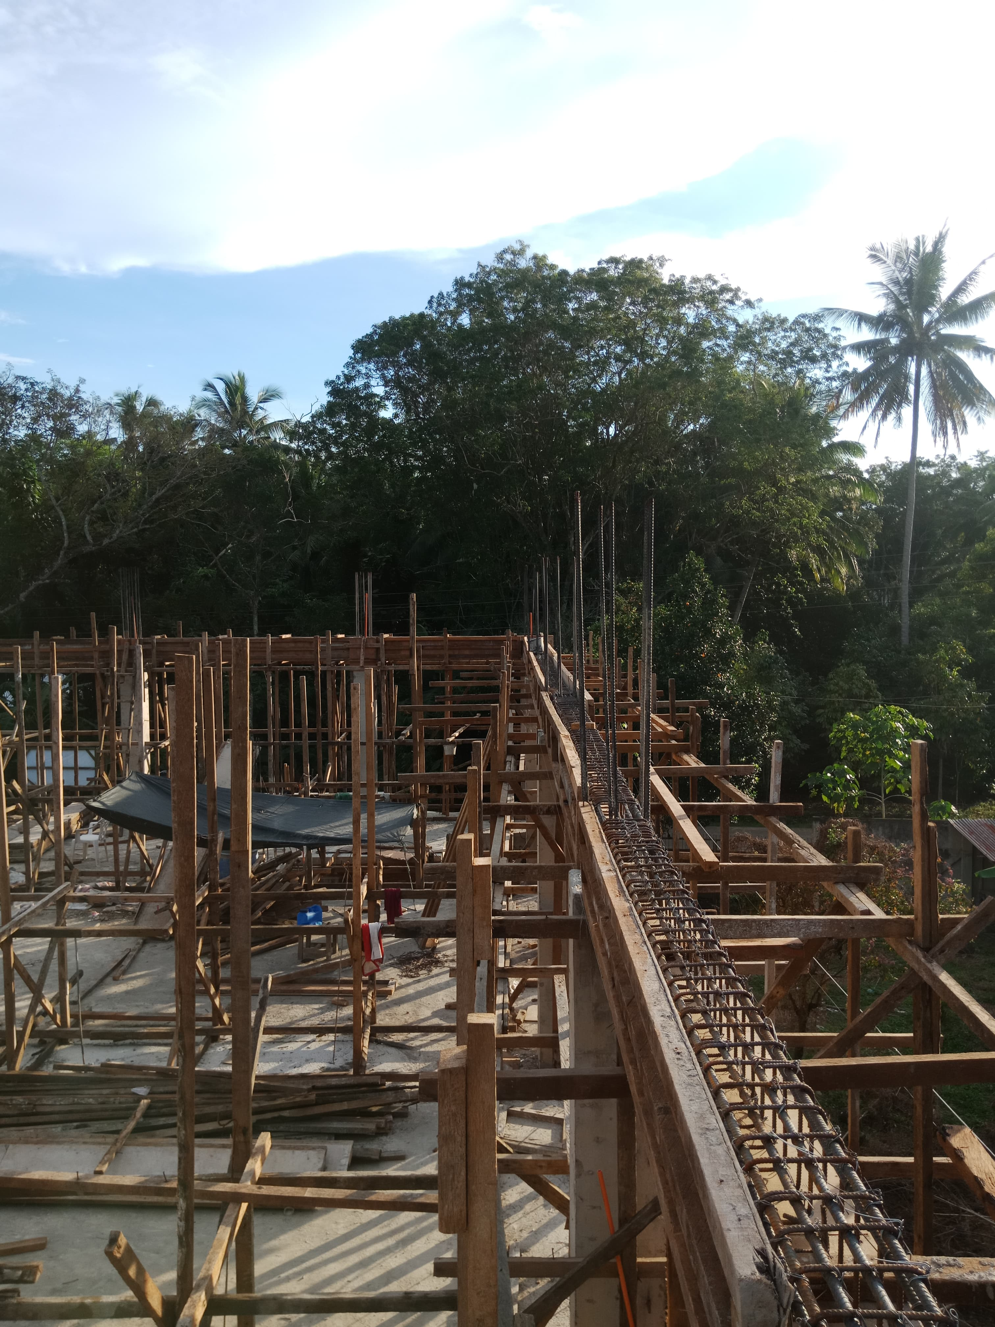

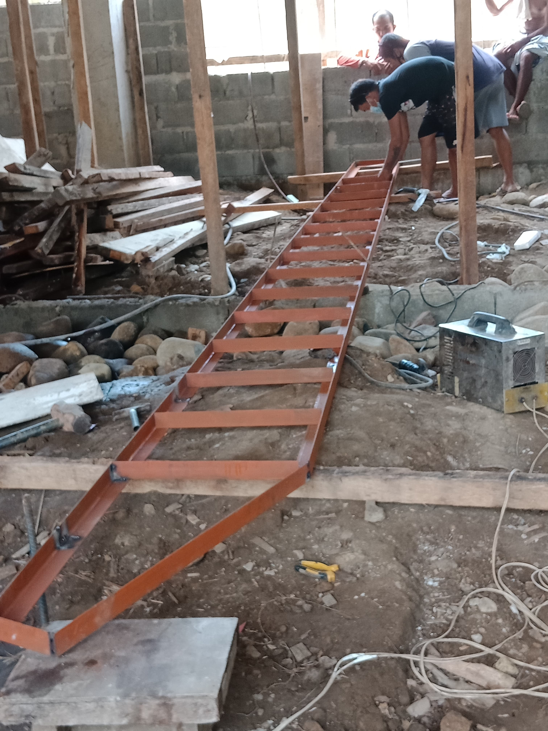

**Register of monies received from U.S. Churches in February 2021:**

Abounding Grace BC, Choctaw, OK $ 75.00

**PHILIPPINE TRAVEL FUND:**

**Beginning Balance 02/01/21: $6,803.78**

Anonymous $100.00

Cross Roads MBC, Hughes Springs, TX $ 50.00

Hart, Bubba & Janet, De Kalb, TX $ 55.00

Stringer, Wayne, De Kalb, TX $ 35.00

**Total Recv’d for Travel – Feb: $ 240.00**

**Travel Fund Ending Balance: $7,043.78**

**----------------------------------------**

**DESIGNATED FOR SALARY:**

Anonymous $100.00

Antioch BC, Center, TX $ 83.50

Austin Chapel MBC, De Kalb, TX $ 50.00

Avery MBC, Avery, TX $ 50.00

Bethel MBC, Ashdown, AR $ 50.00

Bethel MBC, Texarkana, TX $100.00

Bethlehem MBC, Joaquin, TX $ 25.00

Corinth BC, Timpson, TX $100.00

Crestview MBC, Arlington, TX $ 60.00

FBC of Inwood, Inwood, WV $100.00

Hawthorne MBC, Shelbyville, TX $ 50.00

Hillcrest MBC, Paris, TX $ 51.00

Kirbyville MBC, Kirbyville, TX $ 50.00

Liberty MBC, Mt Pleasant, TX $ 50.00

Line Creek MBC, Ida, LA $135.78

Maple Grove MBC, Minden, TX $ 25.00

New Friendship MBC, Benton, AR $156.55

Roquemore MBC, Henderson, TX $ 30.96

White Rock MBC, Center, TX $500.00

Zion Hill BC, Henderson, TX $125.00

**Total Salary Received in Feb: $1,892.79**

**----------------------------------------**

**LOVE OFFERING:**

Parr, Jerry & Martha

Mt Pleasant, TX $ 500.00

Vaughn, Ronnie & Sheila

Hitchcock, TX $ 775.00

Anonymous $ 25.00

Antioch BC, Center, TX $ 83.50

Austin Chapel MBC, De Kalb, TX $ 25.00

Avery MBC, Avery, TX $ 50.00

Bethel MBC, Ashdown, AR $ 50.00

Bethlehem MBC, Joaquin, TX $ 25.00

Blue Ribbon MBC, Lone Grove, OK $150.00

Bogata MBC, Bogata, TX $ 50.00

Concord MBC, Concord, AR $402.33

Cross Roads MBC, Hughes Springs, TX $100.00

Echo Hills MBC, Redwater, TX $ 50.00

Elumbaugh, R.B. & Nina, Center, TX $ 25.00

Ethel MBC, Antlers, OK $ 46.00

Fellowship BC, Joaquin, TX $ 25.00

Fellowship MBC, Pasadena, TX $ 50.00

First BC, Delight, AR $100.00

Grace MBC, Auburn, GA $ 25.00

Grace Temple BC, Mt Pleasant, TX $ 25.00

Green Mountain MBC, Rutland, VT $175.00

Hawthorne MBC, Shelbyville, TX $ 50.00

Hopewell MBC, Ashdown, AR $144.00

Johntown MBC, Bogota, TX $ 60.00

Kirbyville MBC, Kirbyville, TX $ 50.00

Landmark MBC, Athens, TX $100.00

Landmark MBC, Vilonia, AR $ 37.92

Liberty MBC, McKinney, TX $ 25.00

Liberty MBC, Mt Pleasant, TX $ 50.00

Line Creek MBC, Ida, LA $135.78

Longbranch MBC, Carthage, TX $ 50.00

Marlow BC, Marlow, OK $200.00

Mt Pleasant BC, Bradford, AR $100.00

New Haven MBC, Clarksville, TX $100.00

New Liberty MBC, Garland, TX $ 50.00

North Loop BC, Crockett, TX $100.00

Parsons, Terry & Sherry, Benton, AR $400.00

Payne Springs BC, Mabank, TX $163.00

Quaker Avenue MBC, Lubbock, TX $ 25.00

San Augustine MBC, San Augustine, TX $ 15.00

Sublett Road BC, Arlington, TX $ 50.00

Timpson MBC Youth, Timpson, TX $ 50.00

Two Grey Hills MBC, Newcom, NM $ 25.00

Unity MBC, Stuart, VA $ 25.00

Vaughn, Ronnie/Sheila, Hitchcock, TX $200.00

Westside MBC, New Boston, TX $ 84.00

Westview BC, Gatesville, TX $ 25.00

White Rock MBC, Center, TX $ 75.00

Whitton, Cecil & Kay, Timpson, TX $135.00

January Balance $58,262.87

Receive in February for project $ 4,206.53

Amount to account for $62,469.40

Wire transfer (2-01-21) & Wire fee - $ 2,040.00

Wire transfer (2-19-21) & Wire fee - $ 8,040.00

Bal. in designated project account $52,389.40

Amt. reserved for Berean MBC # 14 $16,080.00

Amt. collected for Emanuel MBC next proj. #15 $36,309.40

Amt. needed for Emanuel MBC $13,690.60

Zion Hill BC, Henderson, TX $125.00

**Total Received for Project-Feb: $ 4,206.53**

**Previous Balance: $58,262.87**

**Wire – (02/01/21) Berean MBC - 2,000.00**

**Wire fee - (02/01/21) - 40.00**

**Wire – (02/19/21) - 8,000.00**

**Wire fee – (02/19/21) - 40.00**

**New Bank Balance: $52,389.40**