

**Philippine Mission Development**

P.O. Box 31

New Boston, TX 75559

***Wayne Stringer Director of Promotions***

Phone 903-277-3590 903-667-9048

**www.philippinemissiondevelopment.org**



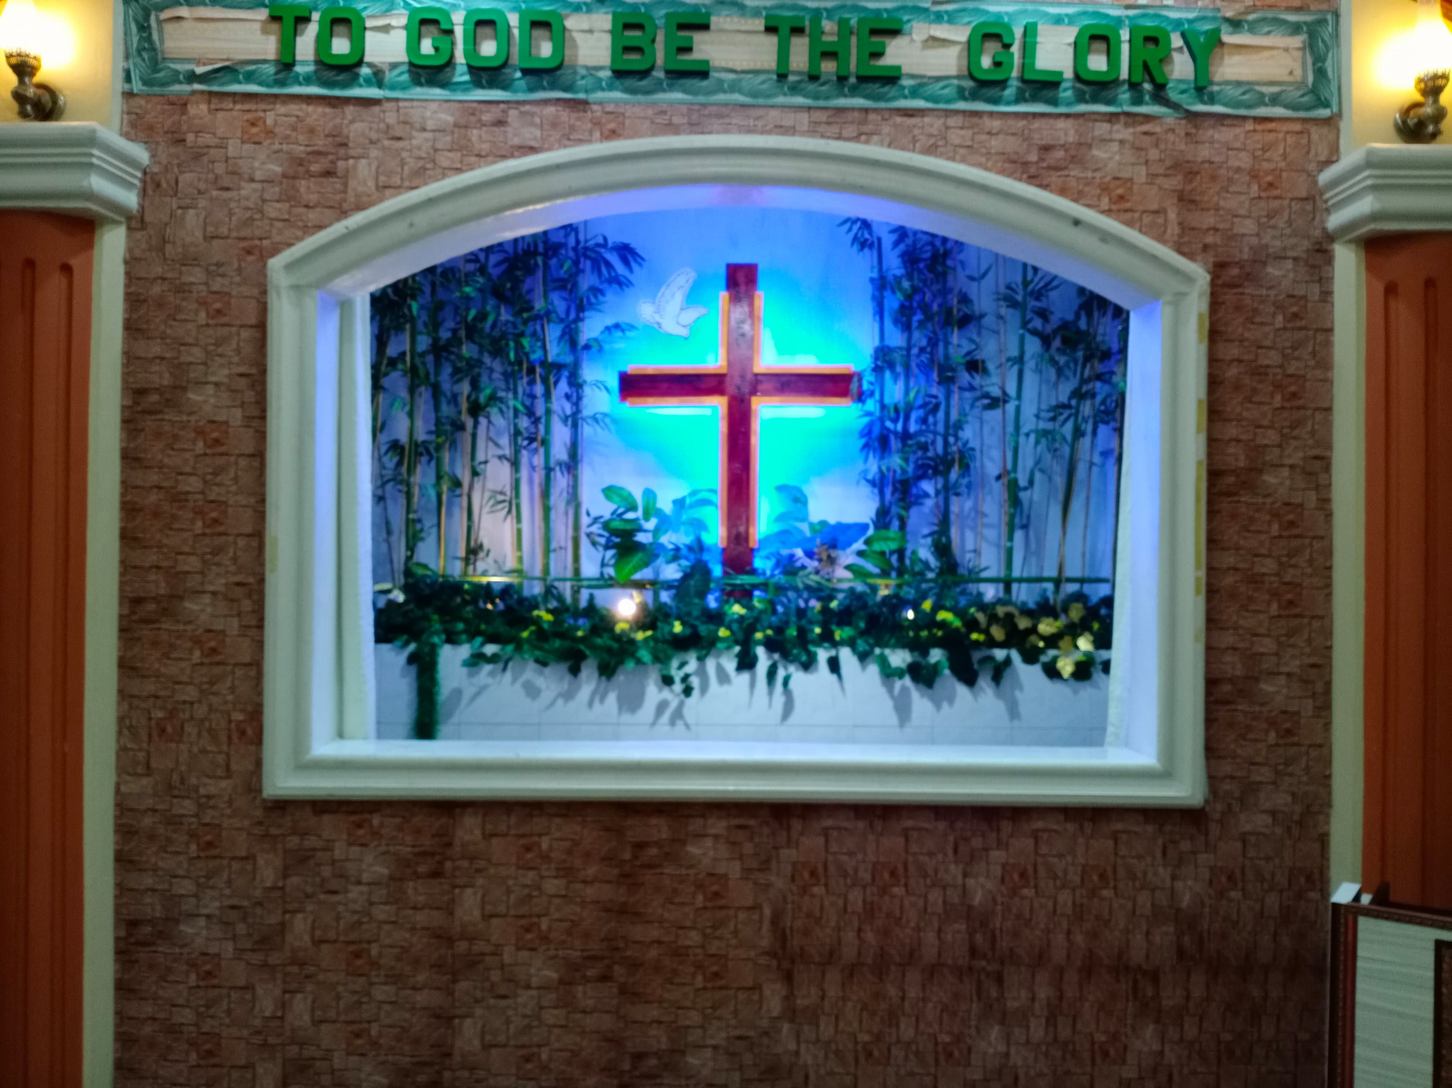

Ind. Calvary #2 up dates their Baptistery

Building forms

Ready to frame and pour roof beams

Members working together

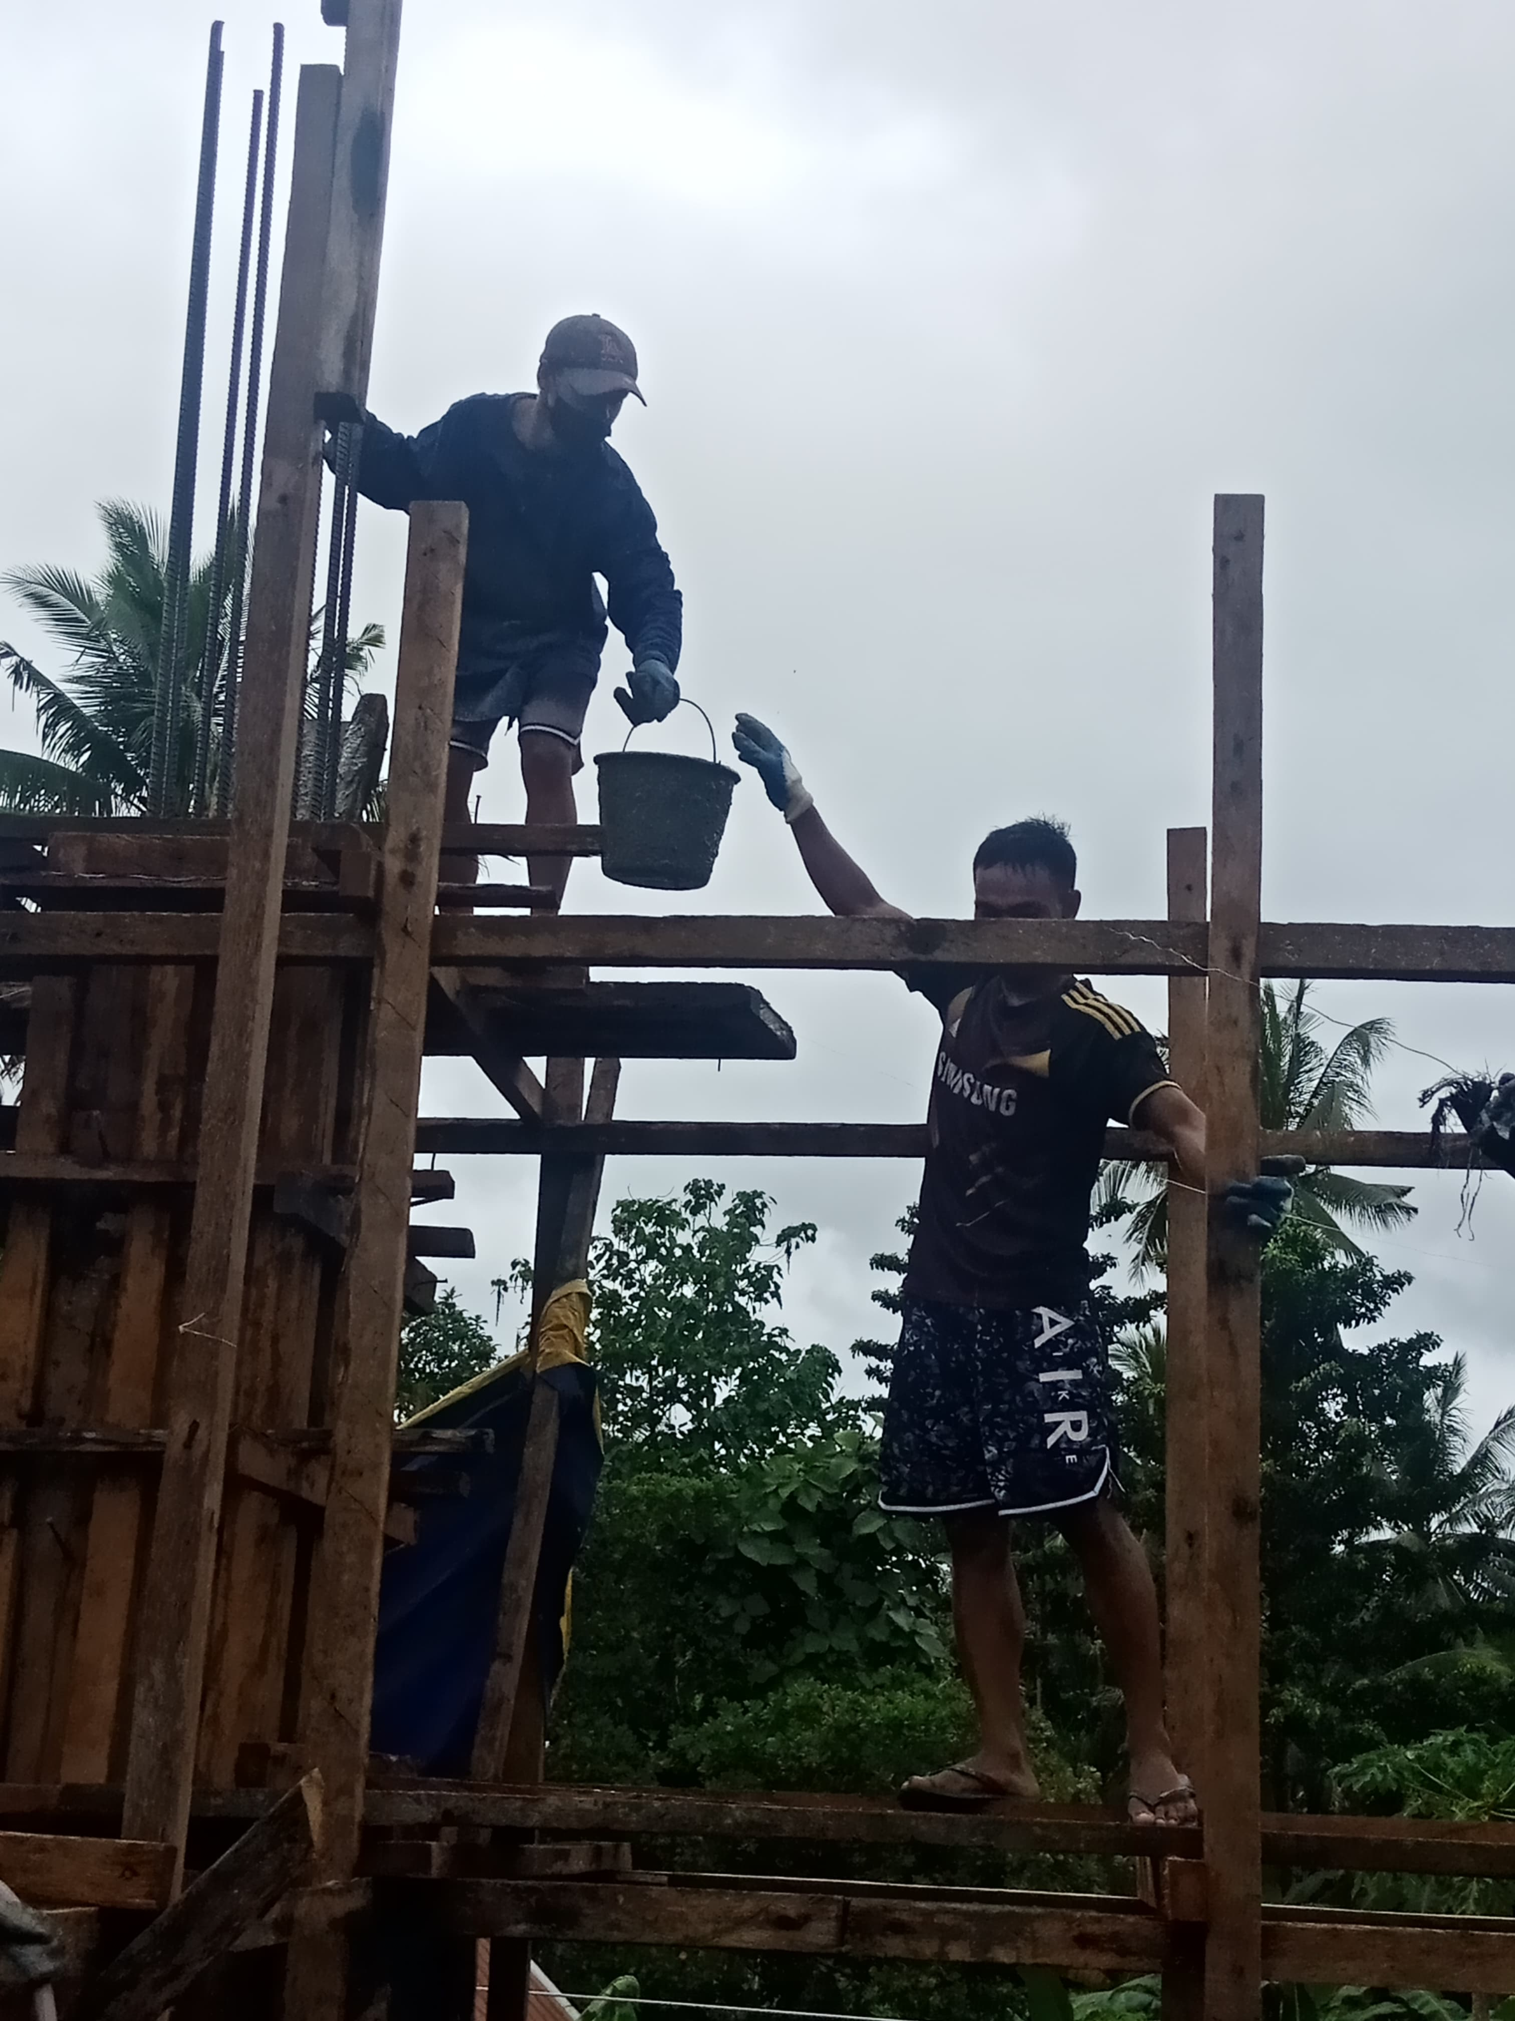

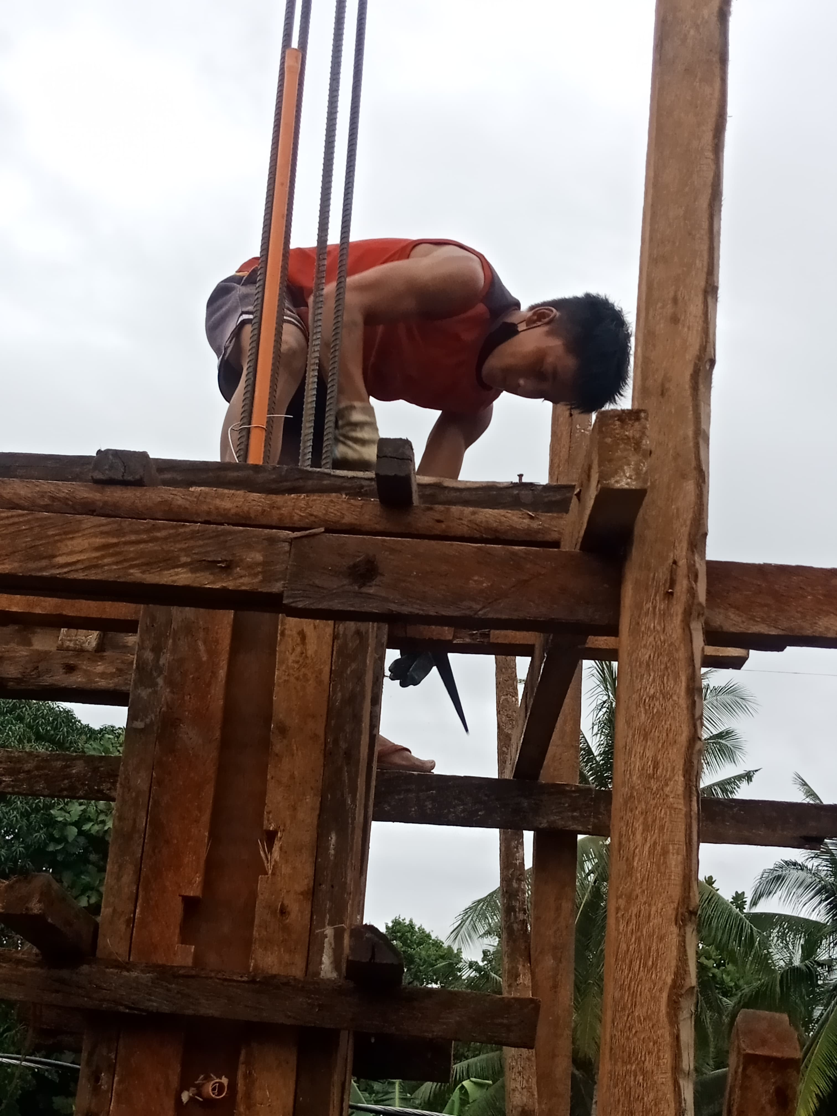



January 2021 Report

January was a very good month for PMD. The work on project number fourteen, Berean MBC is going great; they have been able to work without any delays. At the writing of this report they are ready to begin forming and pouring the roof beams.

The Pastor and church are very excited and the members are involved in the construction by helping any way they can. There is much excitement even in the community because of the building, as a result there were ten new converts baptized recently.

We were privileged to be with four different churches in the month of January. It felt good to be able to visit and share PMD; we were with Antioch Baptist Church, Unity Baptist Church, Pinkam Memoral Baptist Church and Austin Chapel MBC. Two of them, I was given the opportunity to preach, in one I presented PMD, the other was already a supporter, so I gave an updated report and preached, the other two we just visited. If there are new churches that would like for us to visit and share PMD, or if one of the regular supporters would like for us to present a report in person please contact us at the above phone numbers or messenger us on Face Book, we would love to be with you.

Offerings were especially good this month. We received $5,528.73.for the project fund, the rest of the financial report is on the back of this part of the report. As stated in our earlier report, we have received all the funds needed for # 14, Berean MBC. At the end of January they have drawn $24,000.00, this leaves $26,000.00 still reserved for their project.

I praise God for the continued support from all of you, both individuals and churches. You are the ones that make this ministry possible. I look back to the meager beginning and see how God has blessed in such a might way. To see how churches and individuals see the opportunity, the need and continue to be a part. Then to see the beautiful church buildings become a reality; to see the churches and pastors of the Philippines so appreciative and taking advantage of the tools given them to further the spread of the Gospel message in their own country,

Again, Thank You, God Loves you and so do I.

***Wayne Stringer Director of Promotions***

Berean MBC Baptized ten new converts..



**Register of monies received from U.S. Churches in January 2021:**

Abounding Grace BC, Choctaw, OK $ 75.00

**PHILIPPINE TRAVEL FUND:**

**Beginning Balance 01/01/21: $6,613.78**

Anonymous $100.00

Hart, Bubba & Janet, De Kalb, TX $ 55.00

Stringer, Wayne, De Kalb, TX $ 35.00

**Total Recv’d for Travel – Jan: $ 190.00**

**Travel Fund Ending Balance: $6,803.78**

**----------------------------------------**

**DESIGNATED FOR SALARY:**

Anonymous $100.00

Antioch BC, Center, TX $ 83.50

Avery MBC, Avery, TX $ 50.00

Bethel MBC, Ashdown, AR $ 50.00

Bethel MBC, Texarkana, TX $200.00

Bethlehem MBC, Joaquin, TX $ 25.00

Corinth BC, Timpson, TX $100.00

Crestview MBC, Arlington, TX $ 60.00

Faith BC, Homer, LA $ 81.40

FBC of Inwood, Inwood, WV $100.00

Hawthorne MBC, Shelbyville, TX $ 50.00

Kirbyville MBC, Kirbyville, TX $ 50.00

Liberty MBC, Mt Pleasant, TX $ 50.00

Line Creek MBC, Ida, LA $ 47.88

Maple Grove MBC, Minden, TX $ 25.00

Old Salem MBC, Center, TX $200.00

Roquemore MBC, Henderson, TX $ 21.40

White Rock MBC, Center, TX $500.00

Zion Hill BC, Henderson, TX $125.00

**Total Salary Received in Jan: $1,919.18**

**----------------------------------------**

**LOVE OFFERING:**

Parr, Jerry & Martha

Mt Pleasant, TX $ 500.00

Anonymous $ 25.00

Antioch BC, Center, TX $ 83.50

Avery MBC, Avery, TX $ 50.00

Bethel MBC, Ashdown, AR $ 50.00

Bethlehem MBC, Joaquin, TX $ 25.00

Blue Ribbon MBC, Lone Grove, OK $250.00

Bogata MBC, Bogata, TX $ 50.00

Concord MBC, Concord, AR $312.32

Echo Hills MBC, Redwater, TX $ 50.00

Elumbaugh, R.B. & Nina, Center, TX $ 25.00

Ethel MBC, Antlers, OK $ 85.00

Fellowship BC, Joaquin, TX $ 25.00

Fellowship MBC, Pasadena, TX $ 50.00

First BC, Delight, AR $100.00

Grace MBC, Auburn, GA $ 25.00

Green Mountain MBC, Rutland, VT $175.00

Hawthorne MBC, Shelbyville, TX $ 50.00

Hemphill MBC, Hemphill, TX $ 25.00

Hopewell MBC, Ashdown, AR $158.00

Johntown MBC, Bogota, TX $ 60.00

Kirbyville MBC, Kirbyville, TX $ 50.00

Landmark MBC, Athens, TX $100.00

Landmark MBC, Vilonia, AR $ 64.51

Liberty MBC, McKinney, TX $ 25.00

Liberty MBC, Mt Pleasant, TX $ 50.00

Liberty Hill MBC, Mt Pleasant, TX $172.00

Line Creek MBC, Ida, LA $ 47.88

Longbranch MBC, Carthage, TX $ 50.00

Marlow BC, Marlow, OK $200.00

Mt Carmel MBC, Bradford, AR $ 50.00

Mt Pleasant BC, Bradford, AR $100.00

Nevill’s Chapel MBC, Mt Pleasant,TX $682.09

New Haven MBC, Clarksville, TX $100.00

New Liberty MBC, Garland, TX $ 50.00

Old Salem MBC, Center, TX $200.00

Orion MBC, Redfield, AR $383.00

Parsons, Terry & Sherry, Benton, AR $400.00

Payne Springs BC, Mabank, TX $146.43

Quaker Avenue MBC, Lubbock, TX $ 25.00

San Augustine MBC, San Augustine, TX $ 15.00

Timpson MBC Youth, Timpson, TX $ 50.00

Two Grey Hills MBC, Newcom, NM $ 25.00

Unity MBC, Stuart, VA $ 25.00

Vaughn, Ronnie/Sheila, Hitchcock, TX $300.00

Balance last Report $ 60.774.14

Received in Jan. for Project $ 5,528.73

Bal. $ 66,302.87

Wire $8,000.00 + $40.00 Tr. Fee - $ 8,040.00

Balance in Bank to account for $ 58,262.87

Balance reserved for Berean MBC $ 26,000.00

Amount collected for Emanuel MBC$ 32,262.87

**Amount still needed for # 15 Emanuel MBC**

**$ 17,737.13**

Westside MBC, New Boston, TX $ 59.00

Westview BC, Gatesville, TX $ 25.00

White Rock MBC, Center, TX $ 75.00

Whitton, Cecil & Kay, Timpson, TX $135.00

Zion Hill MBC, Batesville, AR $ 50.00

Zion Hill BC, Henderson, TX $125.00

**Total Received for Project-Jan: $ 5,528.73**

**Previous Balance: $60,774.14**

**Wire – (01/06/21) Berean MBC - 8,000.00**

**Wire fee - (01/06/21) - 40.00**

**New Bank Balance: $58,262.87**