

I would like to begin this report with a big thank you to all of you that helped to make our Christmas a bit brighter with the many cards and special Christmas gifts. Words do not adequately express Novis and my appreciation for the love shone to us during this Christmas Season, May God Bless each of you. We were also blessed with being with all of our family at one time or another. We were pleased that Zack, Katie and the boys were able to be here for Christmas.

December was a good month for all aspects of PMD. The offerings were good and the work on Project #14, Berean MBC is going well in spite of all the problems with the Pandemic. We did have some problems with a wire transfer and the funds were delayed, but it has been corrected and the funds are back in our account.

Our ability to move among the churches has been hampered, but we are praying that in the New Year things will settle down and we will have the opportunity to again visit with churches.

For the month we received $4,387.43 for the project fund, the rest of the financial report is on the reverse side of this report. As we have previously reported, we have all the funds for Project #14; they have drawn $24,000, and have $36,000 still set aside for their project. For Project #15 we have collected $ 26,774.14, and need $23,225.86 before moving to project #16.

I am thankful that God continues to bless even though many of our churches are hurting, I believe this is a sign of the importance of this ministry.

May God continue to bless each of you?

God loves you and so do we.

**Wayne Stringer Director of Promotions**

Almost ready to pour floor 2nd floor

2 from children’s ministry gave their all



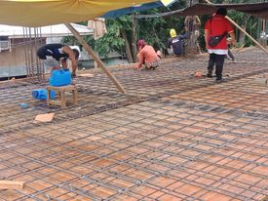

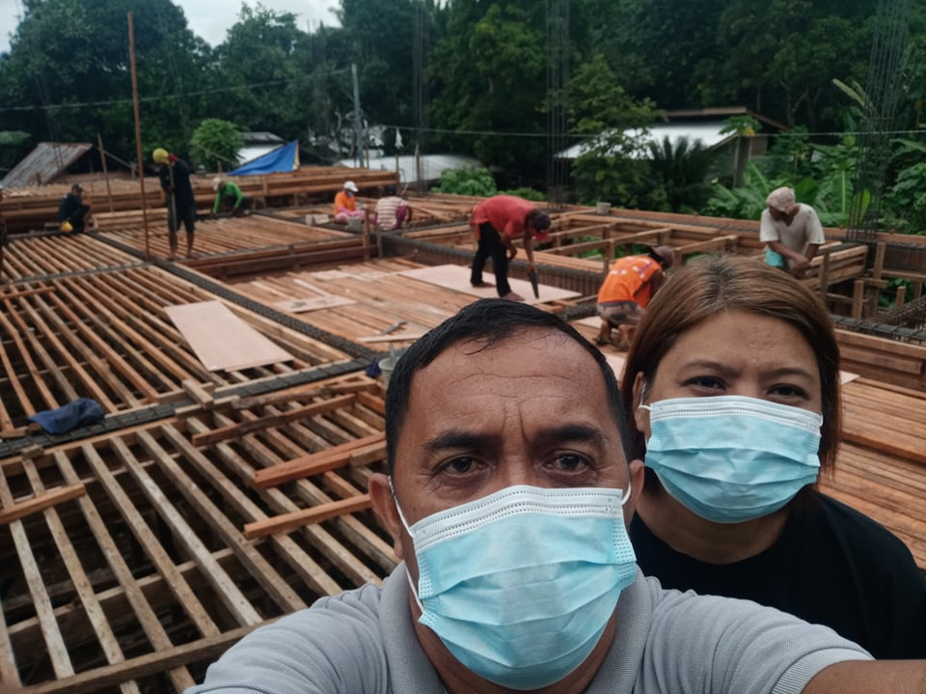

Pastor Albert and His Good Wife

December 2020 Report



**Philippine Mission Development**

P.O. Box 31

New Boston, TX 75559

***Wayne Stringer Director of Promotions***

Phone 903-277-3590 903-667-9048

**Register of monies received from U.S. Churches in December 2020:**

Abounding Grace BC, Choctaw, OK $ 75.00

**PHILIPPINE TRAVEL FUND:**

**Beginning Balance 12/01/20: $6,286.28**

Anonymous $100.00

Cross Road MBC, Hughes Springs, TX $100.00

Hart, Bubba & Janet, De Kalb, TX $ 55.00

Rocky Branch MBC, Omaha, TX $ 37.50

Stringer, Wayne, De Kalb, TX $ 35.00

**Total Recv’d for Travel – Dec: $ 327.50**

**Travel Fund Ending Balance: $6,613.78**

**----------------------------------------**

**DESIGNATED FOR SALARY:**

Anonymous $100.00

Antioch BC, Center, TX $ 83.50

Austin Chapel MBC, De Kalb, TX $ 50.00

Avery MBC, Avery, TX $ 50.00

Bethel MBC, Ashdown, AR $ 50.00

Bethlehem MBC, Joaquin, TX $ 25.00

Corinth BC, Timpson, TX $100.00

Crestview MBC, Arlington, TX $ 60.00

Faith BC, Homer, LA $ 59.10

FBC of Inwood, Inwood, WV $100.00

Hawthorne MBC, Shelbyville, TX $ 50.00

Hillcrest MBC, Paris, TX $ 53.00

Kirbyville MBC, Kirbyville, TX $ 50.00

Liberty MBC, Mt Pleasant, TX $ 50.00

Line Creek MBC, Ida, LA $176.40

Maple Grove MBC, Minden, TX $ 25.00

Old Salem MBC, Center, TX $100.00

Rocky Branch MBC, Omaha, TX $ 37.50

Roquemore MBC, Henderson, TX $ 20.02

White Rock MBC, Center, TX $500.00

Zion Hill BC, Henderson, TX $125.00

**Total Salary Received in Dec: $1,864.52**

**----------------------------------------**

**LOVE OFFERINGS:**

Anonymous $1,000.00

Bethel MBC

Texarkana, TX $ 500.00

Parr, Jerry & Martha

Mt Pleasant, TX $1,000.00

Anonymous $ 25.00

Antioch BC, Center, TX $ 83.50

Austin Chapel MBC, De Kalb, TX $ 25.00

Avery MBC, Avery, TX $ 50.00

Bethel MBC, Ashdown, AR $ 50.00

Bethlehem MBC, Joaquin, TX $ 25.00

Blue Ribbon MBC, Lone Grove, OK $150.00

Bogata MBC, Bogata, TX $ 50.00

Concord MBC, Concord, AR $368.17

Cross Roads MBC, Hughes Springs, TX $200.00

Echo Hills MBC, Redwater, TX $ 50.00

Elumbaugh, R.B. & Nina, Center, TX $ 25.00

Fellowship BC, Joaquin, TX $ 25.00

Fellowship MBC, Pasadena, TX $ 50.00

First BC, Delight, AR $100.00

Grace MBC, Auburn, GA $ 25.00

Grace Temple BC, Mt Pleasant, TX $ 50.00

Green Mountain MBC, Rutland, VT $175.00

Hawthorne MBC, Shelbyville, TX $ 50.00

Hopewell MBC, Ashdown, AR $132.00

Johntown MBC, Bogota, TX $ 60.00

Kirbyville MBC, Kirbyville, TX $ 50.00

Landmark MBC, Athens, TX $100.00

Landmark MBC, Vilonia, AR $ 78.10

Liberty MBC, Mt Pleasant, TX $ 50.00

Line Creek MBC, Ida, LA $176.40

Longbranch MBC, Carthage, TX $ 50.00

Marlow BC, Marlow, OK $200.00

Mt Carmel Ladies Auxiliary $ 30.00

Mt Carmel MBC, Bradford, AR $ 50.00

Mt Pleasant BC, Bradford, AR $100.00

New Haven MBC, Clarksville, TX $100.00

New Liberty MBC, Garland, TX $ 50.00

Old Salem MBC, Center, TX $100.00

Parsons, Terry & Sherry, Benton, AR $400.00

Payne Springs BC, Mabank, TX $142.26

Quaker Avenue MBC, Lubbock, TX $ 25.00

San Augustine MBC, San Augustine, TX $ 15.00

Sublett Road BC, Arlington, TX $ 50.00

Timpson MBC Youth, Timpson, TX $ 50.00

Two Grey Hills MBC, Newcom, NM $ 25.00

Unity MBC, Stuart, VA $ 25.00

Vaughn, Ronnie/Sheila, Hitchcock, TX $200.00

Previous Bal. $ 64,410.26

Rec. December 4,387.43

Balance $68,797.69

Wire Transfer 12/15 8,000.00

Wire fee 40.00

Wire Transfer 12/26 (Bank sent wrong place) 8,000.00

Wire transfer fee 40.00 Bal. 52,717.69

Interest paid 16.45 Bal. in Bank $52,734.14

Amount to be returned 8,040.00

Amount to account for after return $60,774.14

Amount still in account for #14 $ 34,000.00

Amount collected in account for # 25 $ 26,774.14

Total 60,774.14

Westside MBC, New Boston, TX $ 57.00

Westview BC, Gatesville, TX $ 25.00

White Rock MBC, Center, TX $ 75.00

Whitton, Cecil & Kay, Timpson, TX $195.00

Zion Hill BC, Henderson, TX $125.00

**Total Received for Project-Dec: $ 4,387.43**

**Previous Balance: $64,410.26**

**Wire – (12/21/20) Berean MBC - 8,000.00**

**Wire fee - (12/21/20) - 40.00**

**Interest Paid – (12/31/20) + 16.45**

**New Bank Balance: $60,774.14**