



The top three pictures to the right are of 21 baptisms in three of the churches helped by PMD recently. This is what it is all about, getting the Gospel out in the community and elsewhere., The bottom picture is of Christin MBC, Project #9 hosting a ladies fellowship.

November was a good month in many different ways, we enjoyed Thanksgiving with our daughter and her family. Tthe offerings are still good, the work on Project #14 is going well and we are thankful to get back out on the road visiting with the churches. We were able to visit with Marlow MBC and Orin MBC. It was good to be out among the churches. Although, after being with Orin MBC in their evening service, our faith was tested. It was dark and we were out in the country near Sheridan, AR. Rather than drive the 2 ½ to 3 hours home we decided to find a motel. As we entered the city limits of Sheridan, the speed limit dropped to 45, so we slowed down, it was a God thing, because if we had been going faster we could have gotten hurt bad. As it was we were almost stopped before hitting a big buck standing in the middle of our lane, we did not hit him hard enough to kill him, but he did over $5,000.00 damage to our Chev Equinox. We were able to drive the vehicle away and later home the next morning. After it was all over we realized how blessed we were and praised God for keeping us save.

On a much brighter note, Project # 14, Berean MBC is going well and they are presently working on framing up for the second floor.

As previously stated we have all the funds needed for Berean MBC and have turned our attention to receiving funds for projct # 15. For the month we received **$ 3,689.29** for the project fund. The balance in the Bank, after wiring $7,000.00 pluss $40. wire fee *is $64,410.*26, of this $42,000. Is set aside for Berean MBC and $22,410.26 belongs to Project #15. The amount needed to complete #15 is $27,589.74.

Again thank you for your continued support, our prayer is for God to bless each of you for your love of Missions and Missionaries.

Wayne Stringer – Director of Promotions

November Report 2020

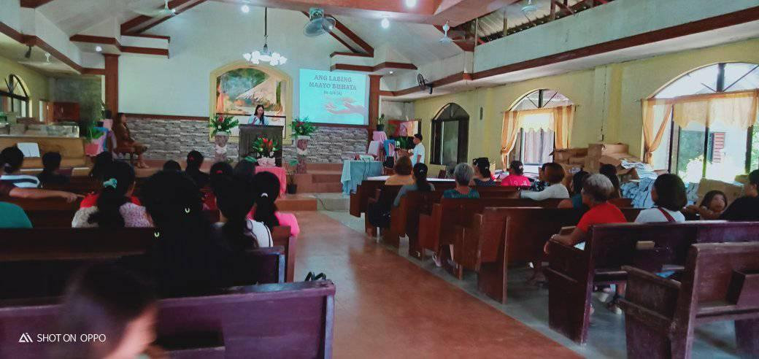

Magalang MBC

Ind. Calvary MBC

Butuan MBC

The three picture below are of the still being added for 2nd floor

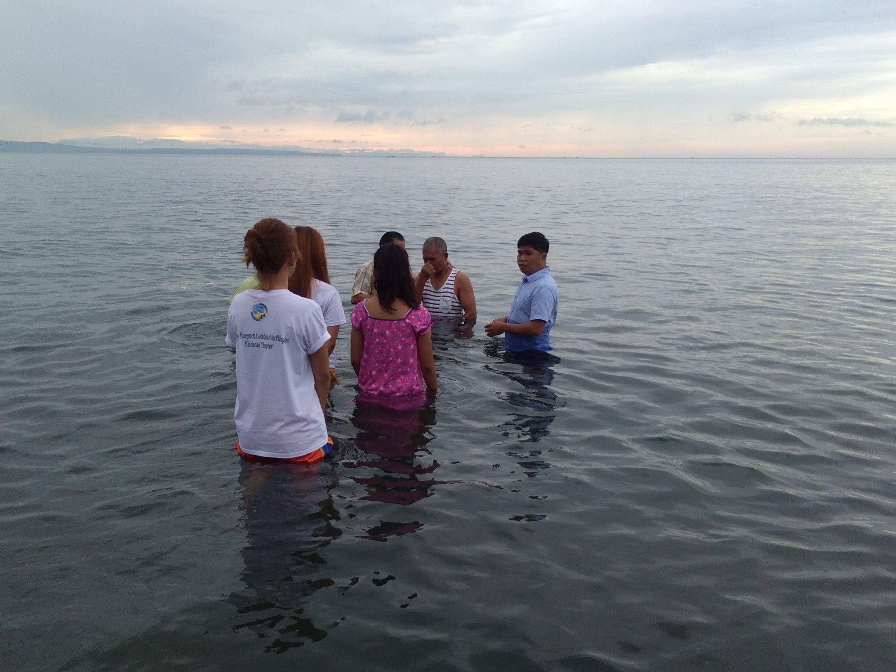



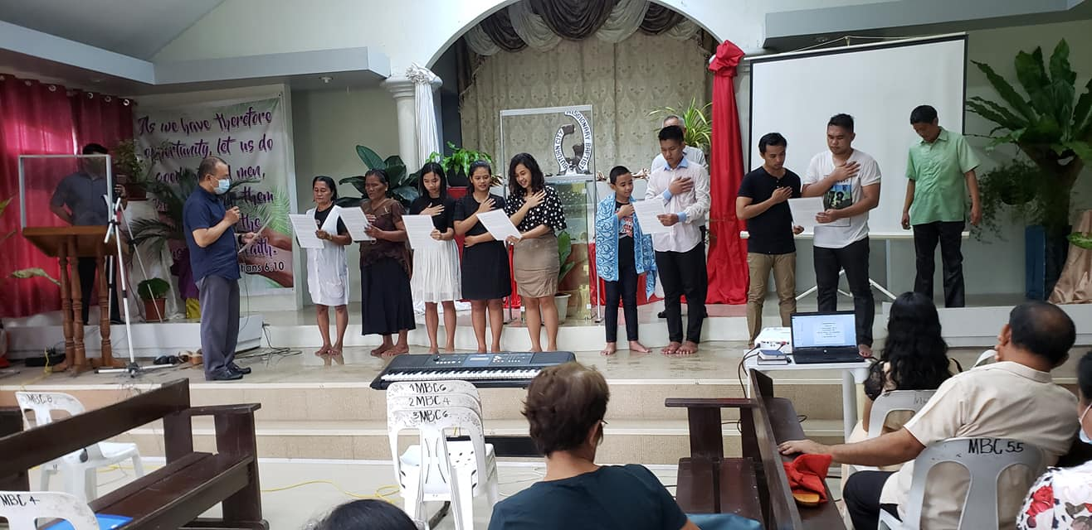





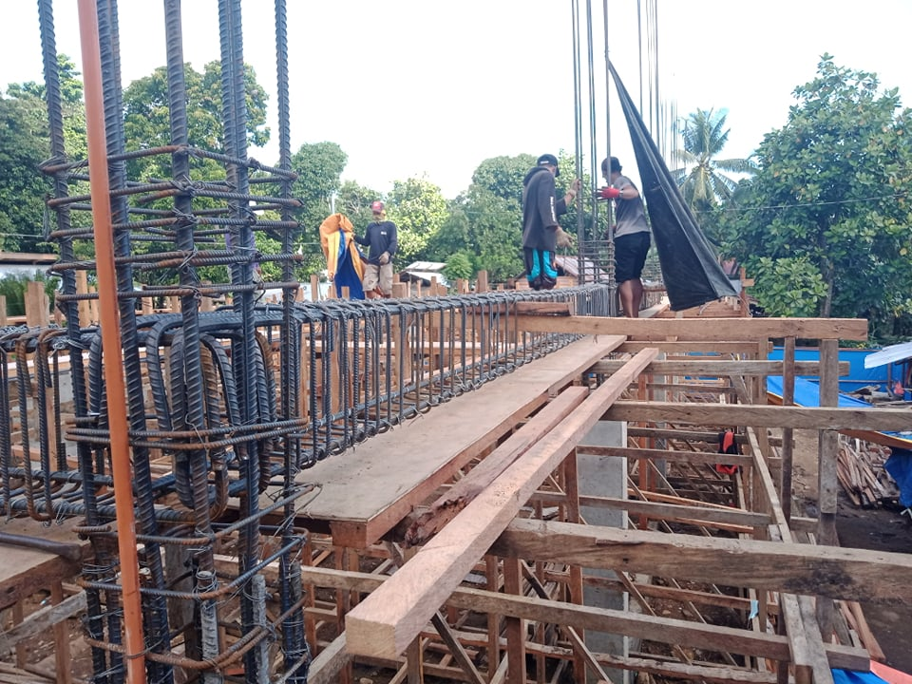

***We wish you a Merry Christmas and a Blessed New Year; may it be one that will bring Honor and Glory to our Blessed Lord.***

**Register of monies received from U.S. Churches in November 2020:**

Abounding Grace BC, Choctaw, OK $ 75.00

**PHILIPPINE TRAVEL FUND:**

**Beginning Balance 11/01/20: $6,146.28**

Cross Road MBC, Hughes Springs, TX $ 50.00

Hart, Bubba & Janet, De Kalb, TX $ 55.00

Stringer, Wayne, De Kalb, TX $ 35.00

**Total Recv’d for Travel – Nov: $ 140.00**

**Travel Fund Ending Balance: $6,286.28**

**----------------------------------------**

**DESIGNATED FOR SALARY:**

Antioch BC, Center, TX $ 83.50

Austin Chapel MBC, De Kalb, TX $ 50.00

Avery MBC, Avery, TX $ 50.00

Bethel MBC, Ashdown, AR $ 50.00

Bethel MBC, Texarkana, TX $100.00

Bethlehem MBC, Joaquin, TX $ 25.00

Corinth BC, Timpson, TX $100.00

Crestview MBC, Arlington, TX $ 60.00

Faith BC, Homer, LA $ 74.57

FBC of Inwood, Inwood, WV $100.00

Hillcrest MBC, Paris, TX $ 61.00

Kirbyville MBC, Kirbyville, TX $ 50.00

Maple Grove MBC, Minden, TX $ 25.00

New Friendship MBC, Benton, AR $200.00

Old Salem MBC, Center, TX $100.00

Roquemore MBC, Henderson, TX $ 24.29

White Rock MBC, Center, TX $500.00

Zion Hill BC, Henderson, TX $125.00

**Total Salary Received in Nov: $1,778.36**

**----------------------------------------**

**LOVE OFFERINGS:**

Anonymous $1,500.00

Liberty MBC, $ 400.00

Mc Kinney, TX

Vaughn, Ronnie & Sheila, $ 700.00

Hitchcock, TX

Anonymous $175.00

Antioch BC, Center, TX $ 83.50

Austin Chapel MBC, De Kalb, TX $ 25.00

Avery MBC, Avery, TX $ 50.00

Bethel MBC, Ashdown, AR $ 50.00

Bethlehem MBC, Joaquin, TX $ 25.00

Blue Ribbon MBC, Lone Grove, OK $150.00

Bogata MBC, Bogata, TX $ 50.00

Concord MBC, Concord, AR $ 88.69

Cross Roads MBC, Hughes Springs, TX $100.00

Echo Hills MBC, Redwater, TX $ 50.00

Elumbaugh, R.B. & Nina, Center, TX $ 25.00

Ethel MBC, Antlers, OK $ 43.00

Fellowship BC, Joaquin, TX $ 25.00

Fellowship MBC, Pasadena, TX $ 50.00

First BC, Delight, AR $100.00

Grace MBC, Auburn, GA $ 25.00

Green Mountain MBC, Rutland, VT $175.00

Hopewell MBC, Ashdown, AR $112.00

Johntown MBC, Bogota, TX $ 60.00

Kirbyville MBC, Kirbyville, TX $ 50.00

Landmark MBC, Athens, TX $100.00

Landmark MBC, Vilonia, AR $ 58.60

Liberty MBC, McKinney, TX $ 25.00

Longbranch MBC, Carthage, TX $ 50.00

Marlow BC, Marlow, OK $200.00

Mt Pleasant BC, Bradford, AR $100.00

New Haven MBC, Clarksville, TX $100.00

New Liberty MBC, Garland, TX $ 50.00

North Loop BC, Crockett, TX $100.00

Old Salem MBC, Center, TX $100.00

Parsons, Terry & Sherry, Benton, AR $400.00

Payne Springs BC, Mabank, TX $126.50

Quaker Avenue MBC, Lubbock, TX $ 25.00

San Augustine MBC, San Augustine, TX $ 15.00

Sublett Road BC, Arlington, TX $100.00

Timpson MBC Youth, Timpson, TX $ 50.00

Two Grey Hills MBC, Newcom, NM $ 25.00

Unity MBC, Stuart, VA $ 25.00

Westside MBC, New Boston, TX $ 67.00

Westview BC, Gatesville, TX $ 25.00

White Rock MBC, Center, TX $ 75.00

Whitton, Cecil & Kay, Timpson, TX $135.00

Zion Hill MBC, Batesville, AR $ 25.00

AMOUNT TO ACCOUNT FOR BUILDING

Present Project #14, Berean MBC $ 50,000.00

Wired 10-27-20 $1,000.00, 11/30 7,000. - 8,000.00

Balance in account for #14 $ 42,000.00

Balance in Building Accounts $64,410.26

Less amount for Project #14 $42,000.00

Amount collected for Project #15 $22,410.26

**Amount needed to complete #15 $27,589.74**

Zion Hill BC, Henderson, TX $125.00

**Total Received for Project-Nov: $ 3,689.29**

**Previous Balance: $67,760.97**

**Wire – (11/30/20) Berean MBC - 7,000.00**

**Wire fee - (11/30/20) - 40.00**

**New Bank Balance: $64,410.26**